Fig. 3. Zoellneria madsenii. (A) Normal hairs; (B) hair from base with basal cells; (C) ectal excipulum with thinner superficial hyphae; (D) tip of ascus; (E) apothecium; (F) ascus and paraphyses; (G) ascospores.
20 ,am
50 pm
100 pm
1 0 mm
25 gm

82 Zoellneria species from Victoria, Australia
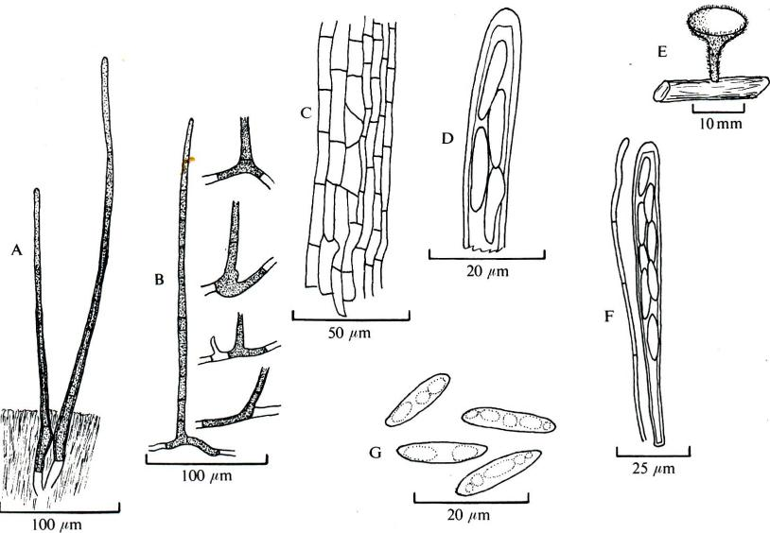

thick. Asci 130-160 (i8o) x 8-i o gm, cylindricalclavate, 8-spored, pore reaction positive in Melzer's reagent. Spores 17-21 x 4.5-5.5 gm, ellipticalfusiform, slightly asymmetrical, uniseriate or irregularly biseriate, hyaline, nonseptate. Paraphyses slightly tapering, septate, simple, same length as asci, tips to 2 gm thick.
Specimens examined. On eucalypt twigs, Grey River Reserve, Otway Range, Victoria, Apr. 1963, G. Beaton 376; on eucalypt twigs, Clearwater Creek, Blackwood, Victoria, May 1966, B. Fuhrer in G. Beaton 328; on the ground, National Park, South Australia, July 1925, J. B. Cleland, WARI 2542; on wood, National Park, South Australia, May 1926, J. B. Cleland, WARI 2545; on twigs, Meningie, South Australia, July 1957, L. D. Williams, WARI 8579; on dead wood, Meningie, South Australia, 1955, L. D. Williams, WARI 6701.
Found in autumn and winter on Eucalyptus twigs and small branches lying on wet ground. A not uncommon fungus throughout Eucalyptus forests in Victoria and has been recorded several times from South Australia. The collection, WARI 2542, from which Hansford's description was prepared is given as Flab. in terra'. The solitary apothecium remaining shows no evidence of having grown on the ground and the broken base of
the stalk suggests its origin on a fragment of wood. As the fungus has never been recorded otherwise except on eucalypt twigs it would seem to be unreasonable to assume that this does not apply to WARI 2542.
Zoellneria clelandii is readily distinguished in the field by its substrate and by always appearing brown from the covering of hairs and brown superficial hyphae.
Zoellneria madsenii Beaton & Weste sp.nov. (Fig. 3)
Apothecia superficiales, dispersa. Discus 14 gm diam, acetabuliformis in pedicello 5 x 1 mm attenuato, parum rugulosus. Margines atque receptaculum per pilos rigidos attenuatos septatos obtecti. Pili in marginibus e hyphis simplicibus, in receptaculo autem e cellulis basalibus pigmentatis enati. Asci clavati, 95-10o x 6.5-8-o gm. Sporae ellipsoideae-fusiformes aseptatae, 12-16 x 3.5-5.5 gm. Paraphyses cylindraceae, septatae, apicibus parum latioribus, longitudine eaedem ac asci, 2.51 m diam.
In ramus emortuis, Melba Gully, Victoria, Decembris 1962, G. Beaton 47, MELD, holotypus.
Apothecia superficial, scattered; disk to 14 mm diam, grey-white when fresh, drying tan, flat or depressed; receptacle saucer-shaped on a tapering

Fig. 4. Zoellneria tax. sp. i (A) Surface view of ectal excipulum with two free clavate cells; (B) transverse section of marginal area showing relative pigmentation and disposition of basal and marginal hairs; (C) structure of medium length hairs; (D) asci and paraphyses; (E) ascospores; (F) transverse section of apothecium, partly diagrammatic.
Gordon Beaton and Gretna Weste
83
^{E}
20 pm
20 pm
50 pm
50 pm

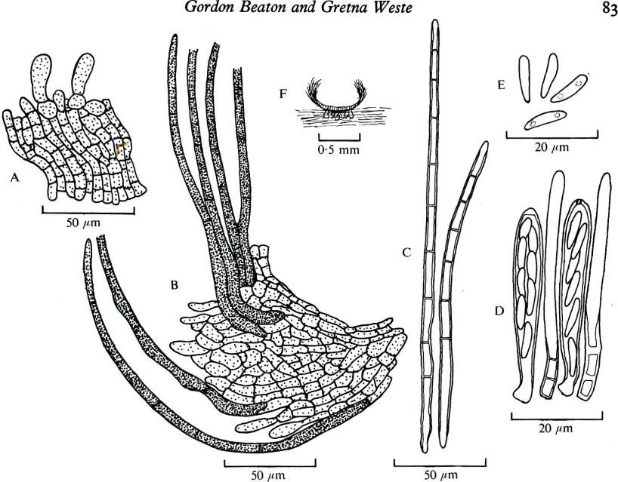

stalk to 5 x 1 mm, slightly rugulose, concolorous with disk when fresh, stalk darker towards base; margin and receptacle covered with evenly distributed, stiff, dark brown, smooth, tapering, obtuse, up to 12-septate hairs to 600 x 7 ,um, those in the marginal area with simple bases and developing as a continuation of a hypha but those in the basal area arising from Y-, L- or T-shaped pigmented basal cells; ectal excipulum a hyaline textura prismatica about 75 ,um thick with cells to 30 x so pm lying parallel to the surface and covered with a few layers of thinner, hyaline, superficial hyphae; medullary excipulum of interwoven hyaline hyphae to 6 /cm thick. Asci 95-110 x 6.5-8 ,um, cylindrical-clavate, 8-spored, pore with a positive reaction in Melzer's reagent. Spores 12-16 X 3.5-5.5 gm, ellipsoidal-fusiform, hyaline, nonseptate, uniseriate or biseriate, with several oil drops. Paraphyses cylindrical with obtuse, slightly thicker tips, same length as asci, septate, 2 pm thick.
On fallen logs and branches in wet places in
spring and summer. Differs from Z. clelandii in the larger apothecia, in the absence of pigmented hyphae from the surface of the receptacle in the smaller asci and ascospores and in the distinctively shaped, pigmented basal cells of the hairs on the receptacle.
Specimens examined. On an unidentified log in a wet area, Melba Gully, near Laver's Hill, Victoria, Dec. 1962, G. Beaton 47, MELU (type); on unidentified logs in wet areas, Mt. Donna Buang, near Healesville, Victoria, Oct. 1975, G. Beaton 378, 378a.
Named in honour of Mr Axel Madsen of Camperdown, Victoria, who for years guarded beautiful Melba Gully in the Otway Range against the advance of agriculture and upon retirement generously gave the whole area to the National Parks Authority.
ZOELLNERIA Tax. sp. I (Fig. 4).
Apothecia superficial, scattered; disk to 0.5 mm diam, grey when fresh, concave; receptacle sessile,

