Lachnaceae & Arachnopezizaceae

Key to genera: still very preliminary

1. Hair wall at least towards base with distinct light- to dark brown pigment ... 2
1. Hair wall hyaline (attention: plasma and/or resin-like exudates may be deep yellowish to ochre-brown)... 9

2. Ap. urnshaped, sessile, margin far protruding, inside with white hair vesture, Sp. 10,5-20/2,5-3,2 µm ................................ Niveostoma leucostoma
2. Cupula ±flat, margin scarcely protruding ................................... 3

3. H. regularly densely granulate-punctate, Ap. short to longstalked ... 4
3. H. smooth or with irregular ±needleshaped-crystalloid deposits, Ap. mostly sessile ........ 6

4. P. broadly lanceolate, far protruding, H. apically with crystal cap (in some finds only sparsely present), septa apically distinctly denser, ect.Exc. t. prismatica ................................................. Brunnipila
4. P. cylindrical to narrowly lanceolate, few protruding, H. without crystals, ect.Exc. t. angularis ..... 5

5. H. in KOH extruding a violet sap, A. IKI bb, ect.Exc. brown, Sp. 4,5-8,5 /2-3 µm ..... Dasyscyphus cerinus
5. H. KOH-, A. IKI-, ect.Exc. ±hyaline .......................... Lachnellula

6. A.-apex IKI-, broadly hemispherical, Sp. suballantoid, 12,5-16/4-4,7 µm, interczellular gel of ect.Exc. IKI red-brown ................... Perrotia flammea
6. A.-apex IKI+, ±konisch, ect.Exc. IKI- .................................. 7

7. Hair wall 0,2-0,5 µm thick, light- to dark brown ............. Lasiobelonium
7. Hair wall 0,5-2 µm thick, deep red-brown ..................... Trichopezizella
7. Hairs rose-brownish ............................ "Albotricha" albotestacea

9. H. at least basally granulate-punctate ............................... 14
9. H. smooth or with irregular needleshaped-crystalloid deposits 10

10. Ap. longstalked, grey, ect.Exc. brown, t. prismatica, H. with oxalate crystals...... Pubigera subvillosula
10. Ap. sessile to short stalked, ect.Exc. hyaline, Ap. without crystals ...... 11

11. H. delicate thinwalled, Sp. 1celled (?Genus) ............................ 12
11. H. firm-walled ......................................................... 13

12. H. c. 50-125 µm long, 1-3celled, Sp. 8,2-12,3/2,8-3,8 µm.. "Albotricha" "aceris-campestris"
12. H. 100-150 µm long, 5-6celled, Sp. 9-12/2-2,3 µm .... "Albotricha" "rengelii"

13. Ap. with pronounced subiculum of (?always) finely granulate hyphae, A. with croziers .... Arachnopeziza
13. Ap. without subiculum, H. pale rose-brownish, A. without croziers.. "Albotricha" albotestacea
13. Trichopeziza!

14. P. ±cylindrical, not or little protruding, Ap. without oxalat crystals 15
14. P. narrowly to broadly lanceolate, not to far protruding, Ap. with or without oxalate crystals ... 16

15. Hymenium yellowish to orange (carotenoids abundant), H. min. 85-125 µm long, ectal excipulum hyaline, KOH- .... Lachnellula
15. Hymenium grey to ochraceous (carotenoids sparse), H. max. 45-53 µm long, ectal excipulum brownish, KOH dirty violet (in Hyphodiscus KOH-)... Proliferodiscus & Hyphodiscus

16. H. with apically firmly attached crystal cap, min. 4,5-6 µm broad, wall min. 0,4-0,7 µm thick, ect.Exc. externally granulate, Ap. white ........... Incrucipulum
16. H. with or without crystals, in upper cylindrical part max. ?3-4 µm broad, ect.Exc. externally smooth ... 17

17. Hair wall 0,3-1,5 µm thick, H. 130-300 µm long, ect.Exc. with ±glassy intercellular gel, Hym. yellowish to orange (carotenoids abundant) ........ Capitotricha
17. Hair wall 0,2-0,4 µm thick, H. max. c. 100-150 µm long, ect.Exc. thinwalled, hymenium white to yellowish (carotenoids absent to sparse) ............... 18

18. H. apically ±far down smooth, extrude hyaline to yellowish resin, P. & H. never with refractive vacuoles .............................. Dasyscyphella
18. H. ±uptoapex granulate, no (yellowish) resin extruded, about half of the species with VBs in H. & P. ................. Lachnum

ARACHNOPEZIZA

1. Sp. filiform, min. 4celled, min. 36-56/max. 2-3 µm, H. thinwalled (c. 0,4-0,6 µm)... 2
1. Sp. oblong-ellipsoid/clavate, 1-2celled, max. 14-23/min. 3-3,5 µm, H. ±thick- walled ... 3

2. Sp. 8celled, 58-79/1,8-3 µm, H. basally not or few, apically non-inflated ... A. aurata
2. Sp. ?6-8celled, c. 50-58/2,2-2,5 µm (tot?), H. c. 120-140 µm, apically clavate inflated.. A. laricina
2. Sp. 4(5)celled, 36-56/2-2,7 µm, H. basally strongly sphaerically inflated A. delicatula/dicrani

3. Sp. 1celled, 10-14/3,3-3,7 µm, Hair wall basally 0,8-1,2 thick A. "gloeophylli"
3. Sp. 2celled, on both ends with long, transient, tail-shaped appendages ... 4

4. Hair wall -1 µm thick, H. yellowish-orange, 150-250/3-4,5 µm, Ap. 1-2 mm, Sp. 11-16/3-3,5 µm ................................................... A. aurelia
4. Hair wall c. 1-2 µm thick, H. hyaline, 120-150/6-7 µm, Ap. 0,3-0,6 mm, Sp. 14-23/3,8- 4,1 µm ........................................................ A. floriphila

LASIOBELONIUM

Many species have a strongly gelatinized stratum between ectal excipulum and inner medulla. This was observed by Spooner (1987 : 582, as "inner part of ectal excipulum") only in L. crosslandii, stating that it "may be diagnostic of the species but does not warrant exclusion from Lasiobelonium". ?All species drought-tolerant??
not yet included: Trichopezizella barbata, also album and lanceolato-paraph.

0. Asci IKI strongly RR, arising from simple septa, *73-88 x 9.5-10 µm, spores *(13) 14-17 (19) x 2.8-3.8 µm, cylindric-subclavate, 1-celled within living mature asci, with medium lipid content (Ölm. 3-3.5), medullary excipulum ??not gelatinized (testen!!!!), paraphyses densely septate, apically covered by densely granular matter, apothecia 0.5-1 mm, drought-tolerant (mostly on hanging twigs), Spain, on wood (rarely bark) of Lonicera periclymenium
L. "sublonicerae"

0.* Asci IKI medium to strongly RB or BB, asci arising from croziers (teste pseudocort.), apices of paraphyses smooth or only with scattered granules apothecia drought-?intolerant (welche??) or tolerant 1

1. Sp. with very low lipid content (Ölm. »1-2), *1.8-3m wide, no gelatinized layer in medulla (---- both species to be tested!), apothecia on wood 2

1.* Sp. with very high lipid content (Ölm. 4.5-5), 2.7-4m broad, medulla towards ectal excipulum of a strongly gelatinized layer with parallel narrow lumina, hairs light ochraceous, straight on flanks and margin, apothecia on bark, rarely on wood 4

2. Hairs on margin 60-100 µm long, on flanks 50-65 µm, straight, spores mostly 1-septate ?within living mature asci, (12) 15-18 (20) x 3 µm, asci »105 µm long, IKI & croziers testen!!!, apothecia (0.5) 1-1.6 mm, on coniferous wood, Alps (980 m) "Lachnum" pseudocorticale
(compare also Lasiob. karatalicum, Picea, endem. in middle Asia)

2.* Marginal hairs »80-120-200 µm long, often strongly flexuous on lower flanks, spores aseptate within living mature asci but later becoming 1-septate, not rarely associated with ochraceous ?sporodochia (anamorph) 3

3. Hairs on flanks strongly curled, 100-270 µm long, marginal hairs straight, walls ----»0.5-1 µm thick in middle part, conidia of anamorph 5-6 x 1.3 µm, ascospores *(9-) 11-14 (-17) x 2.2-2.8 (-3) mm, asci *(60-) 70-80 x 6-7.5 (-8.5) µm, paraphyses * 2.5-4 (-4.5?) µm wide, apothecia 0.7-1.3 mm, on wood of various deciduous trees, XII-VII L. variegatum
(= Sponheimeria crypta) BMDS 173 FT
A completely white form occurred on Salix wood in Graubünden (500m), HB 6944 (no microscopical difference observed).

3.* Hairs ± straight (but in felt around apothecia curled), walls 0.8-1.2 µm thick in middle part, conidia of anamorph 5-9.3 x 0.9-1.1 µm, ascospores *12-23 (-27) x 1.8-2.3 µm, asci ...., paraphyses 3-5 µm wide, apothecia ..., on culms of Poaceae
L. "culmicola"

4. Sp. *10-15 (16.5) x 2.7-3.5 µm, cylindric-fusoid, mostly isopolar, 2-celled within the living fully mature asci, asci *72-103 x 7.5-8.5 µm, apical ring strongly RB (or BB), apothecia 0.3-1 mm, on bark, rarely wood, of Lonicera, ?Viburnum, ?Corylus, Populus, drought-tolerant! L. lonicerae

4.* Sp. (16) 18-27 (31) x 3-3.8 (4) µm, narrowly claviform-fusoid, distinctly heteropolar, 1-celled within the living mature asci, asci *107-130 x 8.5-10.3 (11) µm, apical ring strongly RB, apothecia 0.4-1.5 mm, on bark of Populus, ?drought-tolerant L. corticale

Sponheimeria crypta
Re-examination of the holotype in B (ca. 6 apothecia in very good condition) fully confirmed my assumption that this is a later synonym of L. variegatum. S. crypta is the type species of the monotypic genus Sponheimeria Kirschstein, which is therefore a synonym of Lasiobelonium Ellis & Everh. (non Lasiobeloium ....). Kirschstein's description fully concurs with my data except for shorter asci.

Description of the holotype:
Apothecia dry 0.5-0.8 mm diam., scattered in *alveoles of the bark, strongly hairy-wooly, ochraceous; hairs c. 80-170 x 3.5-4.5 µm, »6-7-celled, bright ochraceous-reddish(-yellowish) except for ± hyaline, slightly tapering tips, strongly flexuous on lower flanks, straight at margin, smooth but with hyaline small crystalloid granules on apex, wall 0.8-1 µm thick; asci KOH 64-68 x 5.8-6.5 (-7) µm, apical ring strongly blue (BB) in IKI, with croziers; ascospores KOH 9.5-14.5 x 2.2-2.5 (-2.7) µm, with few minute LBs in each end, germinating by narrow hyphae, then with a median septum.
8.III.1939, ....

TRICHOPEZIZA

1. Sp. oil content 0-2,5, max. 26 µm long, 1celled .............................. 4
1. Sp. oil content 4-4,5 ...................................................... 2

2. Sp. 11-22,5/1,8-2,5 µm, 1celled, A. IKI rb ............ "Belonidium" lizonii
2. Sp. 33-38/2,5-3,5 µm, ?2-4celled, A. IKI rb .................... T. sulphurea
2. Sp. 55-75/2 µm, at least overmature -16celled, A. IKI bb......... "Belonidium" luteogranulatum

4. Sp. 7,4-11,8/2,7-3 µm, A. IKI ±faintly rb, lignicol ....... T. subsulphurea
4. Sp. longer & narrower, A. IKI medium strongly rb ............................ 5

5. Sp. 12-26/2-2,6 µm, H. with brown resin, which in KOH dissolves red-brown into medium ... "Belonidium" elegantulum
5. Sp. 9-20/1,6-2,4 µm, H. without such resin ................................ 6

6. A. with croziers, H. yellowish to white ............................ T. mollissinus
6. A. without croziers, H. pale yellowish (unclear whether distinct) .......... T. "autumnalis"

TRICHOPEZIZELLA

1. P. apically with granulate deposit, H. 200-350 µm long, not rooting, A. IKI rb .... 2
1. P. smooth, H. 60-170 µm long, deep rooting (in nazarovae presumably not?), A. IKI bb ... 3

2. H. in cylindrical part 3,3-3,8 µm broad, ±flexuos, Sp. 14-20/3,5-4 µm, 2celled, Ap. 1-2 mm, sessile, ect.Exc. t. globulosa, lignicol .............. T. barbata
2. H. in cylindrical part 4-6 µm broad, stiff-straight, Sp. 10-16/2,3-3 µm, 1celled, Ap. 0,5-0,7 mm, short-stalked, ect.Exc. of cuboid cells, caulicol, subalpin ....................................................... T. relicina

3. P. 0-6 µm protruding, 2,5 µm broad, H. 3,2-4 µm broad (in cylindrical part), ?not rooting, ect.Exc. t. prismatica, Sp. 8-13,3/2-2,2 µm, oil content 3 .............................................................. T. ?nazarovae
3. P. 15-30 µm protruding, 5-5,5 µm broad, H. 5,5-6 µm broad (in cylindrical part), rooting deep in ect.Exc. of t. globulosa, Sp. oil content 0 .............. 4

4. A. without croziers, Sp. 6-12/1,5-2,1 µm, A. 50-58/5-6 µm ............... T. nidulus
4. A. with croziers, Sp. 7-15/1,2-2 µm, A. 65-75/5,5 µm (taxon of unclear rank)... T. "subnidulus"

BRUNNIPILA

1. A. with croziers, foliicol/ramicol/fructicol on woody plants .............. 2
1. A. without croziers, foliicol/caulicol on herbs or grasses ....................... 5

2. H. 60-150 µm long, 6-8celled .............................................. 3
2. H. 105-240(330) µm long, 8-10celled ........................................4

3. Sp. 6-10,5/1,2-1,8 µm, H. 60-150 µm long........................ B. fuscescens
3. Sp. 5,5-9,5/1,7-2,7 µm, H. 60-90 µm long (distinct?)........ "Dasyscypha" brunneola

4. Sp. 7-8/2,4-2,8 µm, A. 57-65/6,8-7,5 µm, P. 10 µm protruding, H. KOH- ........ "Dasyscypha" latebricola
4. Sp. 8-15/1,8-2,5 µm, A. 60-70/5-6 µm, P. 20 µm protruding, H. KOH-........... B. calyculiformis
4. Sp. 6-8/2 µm (?mature), H. rather violet in KOH ........ B. ?calyculiformis

5. A. IKI rb, Sp. oil content 3, 11-17/2-3 µm, violet pigment on H. and ect. Exc. (especially on stipe) not rare ...... B. calycioides
5. A. IKI BB/rB, Sp. oil content 0-1 ............................................. 6

6. Sp. 6-10,5 µm long ........................................................ 7
6. Sp. 9-18 µm long (sometimes only 9-12 µm?) ............................. B. palearum

7. Hairs apically not inflated, 2-4-septate, leaves of Rubus ... B. dumorum
7. Hairs apically slightly inflated, usually tipped by crystals, ?5-7-septate .... 8

8. Sp. 6-10/1,2-1,8 µm, H. ±deep brown, never with violet pigment, A. 40-57/4,5-5 µm..... B. clandestinus
8. Sp. 7-10,5/1,6-2,2 µm, H. more light brown, violet pigment on ect.Exc. and H. may occur, A. 50-60/5-6 µm .................................. B. "aruncicola"

Key to European species of Lachnum

1. Hairs (H.) with (medium to abundant) oxalate crystals
2. Paraphyses (P.)/hairs with (medium to abundant) strongly refractive VBs (apothecia turning reddish-brownish with age)
3. Asci (A.) with croziers

crystals | VBs | croziers
+ | + | + | no taxon known
+ | + | - | no taxon known
+ | - | + | subkey 1 (P. always broadly lanceolate, far protruding)
+ | - | - | subkey 2 (Sp. oil content 0-1, H. 3-4celled)
- | + | + | subkey 3
- | + | - | subkey 4
- | - | + | subkey 5 (Sp. within 6-13/1,2-3 µm)
- | - | - | subkey 6

Subkey 1 (+ - +). Substrate: leaves and herbaceous stems

1. Crystals (often globose druses) are very easily removed in water mount, Sp. 4-8/1,3-1,5 µm, oil content 0-1, A. 30-45 µm long.... L. rhytismatis
1. Crystals more firmly attached to hair tip though detaching on pressure.................................... 2

2. Sp. 6-11/1,2-1,5 µm, oil content 1, A. 40-50 µm long, Ap. 0,8-1 mm, stipe 0,3-0,5 mm .... L. morthieri
2. Sp. 9-15/1,7-2,3 µm, oil content 0, A. 65-80 µm long, Ap. 0,7-2,2 mm, stipe 1-2,5 mm ......... L. nudipes

Subkey 2 (+ - -). Substrate: leaves and herbaceous stems

1. Sp. 7-12/2,7-4 µm, A. 50-66/7-9 µm, P. 0-10 µm protruding, crystals often globose druses, in water mount easily removed ...... L. trapeziforme
1. Sp. max. 6-9/1,6-2,1 µm, A. 4-6 µm broad, P. min. 8-15 µm protruding ........... 2

2. Ap. ±sessile (stipee 0-0,2 mm long), turning red despite of absence of VBs........ L. eburneum
2. Ap. stalked (stipe 0,3-0,6 mm long), not reddening ........................ 3

3. A. IKI-, Sp. oil content 2 (biguttulate), crystals firmly attached, Ap. amidst of populations of L. nudipes ..... L. “subnudipes”
3. A. IKI bb, Sp. oil content 0-0,5 ........................................... 4

4. Crystals firmly attached, Sp. 6-10,5/1,5-2,1 µm, Ap. 0,4-1,3 mm, caulicolous......... L. clavigerum
4. Crystals easily removeable, Sp. 4-6/1,2-1,5 µm, Ap. 0,2-0,6 mm, foliicolous.......................... L. microsporum

Subkey 3 (- + +)

1. On wood, H. apically slightly capitate, Sp. max. 12 µm long................. 6
1. On grasses, H. apically mostly non-inflated ............................... 2

2. Sp. 5-9,5/1,2-2,1 µm, oil content 0,5-1, P. 0-15 µm protruding, 3-6 µm broad, H. 40- 90 µm long, apically non-inflated, ?1celled .......................... L. carneolum
2. Sp. 7-15/1,1-1,5 µm, oil content 0,5, P. 15-25 µm protruding, 5-6 µm broad, H. 60-95 µm long, apically non-inflated, 1celled ............................. L. tenuipilosum (= L. elongatisporum)
2. Sp. 9-16,5/1,7-2,3 µm, oil content 1-2, P. 20-25 µm protruding, 5-6 µm broad, H. 40- 115 µm long, apically non-inflated, 1-6celled ................... L. "longipilosum"
2. Sp. 10-19/2-2,5 µm, oil content 2, P. 5-15 µm protruding, 4-5 µm broad, H. 50-85 µm long, apically non-inflated, 1-3celled, to apex guttulate L. "trichophoricola"
2. Sp. 9-18/1,5-2,3 µm, oil content 0-1, P. 5-15 µm protruding, 3,5-6 µm broad, H. 60- 105 µm long, apically partly slightly capitate, 1-5celled, only basally guttulate (find from Gerardmer: P. narrow)................................ L. "riffwili"

6. A. 60-82/6-6,5 µm, Sp. 6-12/1,8-2,8 µm, P. 0-12 µm protruding, 3-5 µm broad, H. 50- 90 µm long, 1-3celled .......................................... L. papyraceum
6. A. only 4,5-5,2 µm broad, Sp. 1,5-2,1 µm broad ............................... 7

7. A. 43-55 µm long, H. 50-85 µm long, 1-5celled, P. 15-30 µm protruding, 4,5-7 µm broad.......... L. fasciculare (= L. fulvellum)
7. A. 48-70 µm long, H. 70-110 µm long, 3-4celled, P. 3-20 µm protruding, 3-5 µm broad (?separate species?) ..................................... L. cf. crataegi (= "virgineorubescens") - Marketa (pers. comm.) thinks that here the names fasciculare and crataegi should be exchanged (IV.2011). HB: I saw the types of fulvellum and fasciculare but perhaps not crataegi. The dimensions in the key are in the living state, so difficult to compare with the dead data. It seems I did not yet scan my virgineorubescens collection which I remember has hairs similar as virgineum, i.e. very long and apically hardly inflated. Maybe crataegi is something different.

Subkey 4 (- + -)

1. Sp. oil content 0-1, sp. max. 8-15 µm long......................................... 2
1. Sp. oil content 4-5, sp. min. 9-17 µm long ...................................... 10

2. H. apically distinctly capitate-clavate .............................................. 3
2. H. apically always ± non-inflated ............................................. 5

3. Sp. 6-11/1,2-1,7 µm, P. 15-30 µm protruding, 4-6 µm broad, VBs hyaline, rarely yellowish, Ap. graminicolous (very rarely caulicolous) ........... L. pudicellum
3. Sp. 5-9/1,5-2 µm, P. 0-15 µm protruding, 4-5 µm broad, VBs yellowish, Ap. lignicolous (separate species?) ............................ L. "flavotinctum"
3. Sp. 6-12,5/2-3 µm, P. 0-9 µm protruding, 3-6 µm broad, VBs hyaline, (H. only slightly capitate), Ap. lignicolous ...................... L. brevipilosum ss. Baral
3. (finds on Salix branches in summer with P. 0-15 µm protruding, A. often with basal protuberance perhaps separate taxon) L. pudibundum (?= L. brevipilosum ss. Le Gal)
3. Unclear collection from Filipendula (Marais Poitevin, 29.IV.2011)

5. P. 0-9 µm protruding, Ap. lignicolous ........................... L. brevipilosum ss. Baral
5. P. (3)10-24 µm protruding, Ap. graminicolous .................................. 6

6. Marginal hairs 40-80 µm long, 1celled, P. densely filled with VBs ..... 7
6. Marginal hairs 35-60 µm long, 2-4celled, P. mostly only with sparse VBs, Sp. 7-14/1,3-2 µm, ±fusoid, Ap. 0,2-0,6 mm ........... L. caricis

7. Sp. 6-10/1,8-2,2 µm, VBs hyaline, Ap. 0,8-1,8 mm, stipe 0,2-1 mm............. L. controversum
7. Sp. 7,5-15/1,9-2,7 µm, VBs yellowish or white, Ap. 0,3-0,8 mm, stipe 0,1-0,2 mm ..... L. winteri

10. Sp. 35-49/1,5 µm .................................................. L. apalum
10. Sp. 9-21 µm long ........................................................ 12

12. Sp. 16-21/3,3-4 µm, A. IKI rb, P. not protruding, Ap. sessile (stipe hidden in substrat).... L. albidoroseum
12. Sp. max. 2,5-3,3 µm broad, A. IKI bb, P. min. 0-15 µm protruding, Ap. short-stalked... 13

13. Sp. 13-21/2,5-3,3 µm, A. 68-103/7.7-9,5 µm, H. 40-70 µm long, 1-3celled (=imbecille ss. Ba.&Kr.), sometimes with yellow VBs .... L. juncinum
13. Sp. max. 2,1-2,3 µm broad, A. 5,5-7 µm broad .............................. 14

14. Sp. 11-17/2,1-2,3 µm, H. 40-65 µm long, 3-4celled, A. 60-73 µm long, P. 30 µm protruding ...... L. "subdiminutum" (Hochmoor in Vosges)
14. Sp. 9-21/1,5-2 µm, H. 30-45 µm long, 1-2celled, A. 45-68 µm long, P. 10-18 µm protruding .... L. diminutum

Subkey 5 (- - +)

1. Sp. oil content 3,5-4,5 µm, Ap. with 1-6 mm long stipe, P. 5-10/2-3,3 µm..... L. salicariae
1. Sp. oil content 0-1 ........................................................ 2

2. Hairs 60-75 µm long, sp. 8-10 x 2.8-3 µm, P. 0-8 µm protruding, 3-4.5 µm wide, hymenium white; Salix wood, Sachsen, HB 8389 ......... L. aff. pygmaeum
2. H. 35-45(70?) µm long, Sp. 7-11(?13)/2-2,5(?3) µm large, P. (0-10?)20-30 µm protruding, 3-4 µm broad, hymenium ± yellowish ............................. L. pygmaeum
2. Marginal hairs 40-60 µm, flank hairs 50-90 µm long, Sp. 5-9/1,5-2,3 µm, P. 6-12 µm protruding, 2,5-3,5 µm broad, hymenium white, overmature ochraceous, ap. lignicolous, Sept.-April (similar collections during June-Oct., paraphyses broader (mostly *3.5-4.5 µm), sp. 4.3-7.5 x 1.9-2.1 µm, perhaps separable as L. pubescens) ....... L. impudicum
2. Marginal hairs 55-70 µm long, Sp. 5-11/1,5 µm, P. 10 µm protruding, ?5 µm broad, Ap. graminicolous .......... L. "Schweigbrühl"
2. Marginal hairs 70-110 µm long .................................................. 3

3. P. 0-10 µm protruding, 3-4,5 µm broad, Sp. 7-12/2,4-3 µm, H. 90 µm long, strongly capitate ....... L. "salicis"
vgl. 2 Funde aus Chemnitz & Mecklenburg!
3. sur brindille sèche de Castanea sativa, Olargues, Mas du Gua, La Chapelle GG03111103, apothécies blanches stipitées, entièrement poilues, paraphyses étroitement lancéolées (ø 2-2,5µ), exertes de moins de 10 µ, 1-2 cloisons surtout vers la base. Asques cylindriques 65-70 x 6 µ, I++ bleu, crochet ++, octospores, à base légèrement retrécie. Poils entièrement incrustées, cylindriques à sommet non élargi, arrondi parfois subconique, ø 3-4 µ, dépassant 100 µ de long. Spores cylindro-oblongues avec une extrémité (l'inférieure) parfois subfusiforme surtout dans l'asque, sans contenu huileux, bisériées ou parfois unisériées dans l'asque, non septées, lisses, 12 x 3 µ … Lachnum masduguae adint . -- Une autre récolte, GG03121402, sur Calluna vulgaris, très copieuse, ne diffère que par des asques atteignant 85 x 6 µ et des paraphyses jusqu'à 3 µ de large, exertes de 15 µ. Spores avec quelques goutellettes (échelle Baral 2-3), mais les specimens sont ultra frais.....Dasyscyphella "callunae" Baral ad. int. -- Mais les poils me semblent typiques des Lachnums !! A mon avis il s'agit de la même espèce.

3. P. 15-30 µm protruding, 5-7 µm broad, Sp. 1,5-2,2 µm broad ..................... 4

4. H. cylindrical, apex completely unenlarged, flank hairs 90-120(-135) µm long, Sp. 6-12/1,7-2 µm, oil content 0, H. & P. typically filled with low-refractive VBs .............................................. L. virgineum
4. H.-apex distinctly capitate, flank hairs 70-90(-110) µm long, Sp. 7-13/1,7-2,2 µm, oil content 1, sometimes only 6-9/1,5-2 µm, oil content 0, P. & H. with single low- to medium refractive plasma guttules .... L. subvirgineum

Subkey 6 (- - -)

1. Sp. min. 14,5-20 µm long, oil content (1.5-)2(-3) schlecht................................... 2
1. Sp. max. 9-18 µm long, oil content 0-1 ....................................... 5

2. Sp. 14,5-26/2,3-2,7 µm, oil content 1,5-3, P. 15-25/4,5-6 µm, H. 3-7celled, towards apex tapered, apex completely unenlarged, paraphyses and hair bases with pale to light orange-red vacuolar sap, therefore apothecia in fresh state with brick-orange-red hymenium, subsessile .................... L. imbecille
2. Sp. 1,6-2,3 µm broad, oil content 2, P. 5-15 µm protruding, 3-6 µm broad, H. 3-5celled, apex slightly capitate, ap. white or sometimes yellow ..................................... 3
3. Sp. (11.5-)13-22(-30) x 1.6-2.2(-2.4) µm, marginal hairs (40-)60-80(-100) µm long, 3-4-celled, apex slightly capitate, Ap.-stipe 0,1-0,2 mm long, Schaffhausen, on Schoenoplectus ........................................................... L. schoenoplecti
3. Sp. (15-)17-28(-32.5) x 1.9-2.3 µm, marginal hairs 50-90 µm long, always slightly capitate, 4-5celled, Ap. (0.3-)0.6-1.1(-1.4) mm diam, stipe 0.2-0.8 mm long, Gerardmer & Lapland, Juncus, Carex, Molinia ...... L. "paraimbecille" (conspecific with schoenoplecti as it seems)
5. Sp. 4,5-8 x 1,3-1,8 µm, A. *41-48/4,3-4,7 µm, hairs 50-90 µm long, apex not or only slightly inflated, ap. subsessile .. L. "reynoutriae"
5. Sp. min. 6-12 µmlong ...................................................... 6

6. Sp. 1-1,5 µm broad, P. 15-30 µm protruding, 4-7,5 µm broad, A. 40-55 µm long...... 7
6. Sp. 1,2-2(2,3) µm broad, A. 45-60(75) µm long................................ 8

7. Sp. 6-11 µm long, marginal hairs 50-75 µm, flank hairs 30-55 µm long, H. strongly capitate ... L. pudicellum
7. Sp. 7-12 µm long, marginal hairs 30-55 µm, flank hairs 20-48 µm long, H. slightly capitate....... L. "subpudicellum"
7. Sp. 7-15 µm long, marginal hairs 70-90 µm, flank hairs 45-90 µm long ...... L. tenue

8. P. 0-15 µm protruding, 2-4 µm broad, Sp. 9-18/1,2-2 µm, A. 45-60 µm long ... L. sesleriae
8. P. 10-25 µm protruding, 4-6,5 µm broad, Sp. 6-15 µm long, A. 50-75 µm long........ 9

9. Sp. 6-12/2,1-2,3 µm, Ap.-stipe 0,4-0,6 mm ................ L. "subreynoutriae"
9. Sp. 7-15/1,5-2,2 µm, Ap.-stipe 1-3 mm .............................. L. elatior

Laevipulum key
Apothecia entirely white, sometimew with yellow disc. Hairs cylindrical, apically not or very lightly inflated, roadest below, 3–4-celled. Crystals (often globose druses) always present (except for L. sp.), but being very easily removed in water mount. Spores cuneate-clavate, always with very low lipid content. Paraphyses broadly lanceolate, strongly protruding. Asci IKI bb.

1. Asci arising from croziers.........................2
1. Asco arising from simple septa........................3

2. Ap. 0.3–0.8 mm diam., stipe 2–5x longer than wide (shorter than disc diam.), disc white, sp. *(4–)5–8(–9) x (1.3–)1.5–2.1 µm, asci *30–45 x 4.7–6.2 µm, hairs *~40–60 x 4–5 µm, 3–4-celled, with crystal balls, Quercus & Acer leaves, frequent .... L. aceriphilum (L. rhytismatis s. auct.)
2. Ap. 0.6–0.8 mm diam., stipe 6–18x longer than wide (longer than disc diam.), sp. *(4.5–)5–8.5(–9.5) x (1.4–)1.6–1.9(–2.2) µm, asci *35–50 x (4–)4.5–5.5(–6) µm, hairs *40–45 x 3.5–4 µm, ?2–3-celled (Asturias), up to 75–95 x (3.5–)4.5–6(–7) µm, 3–4-celled, no crystals seen (or only very few in the sample from Asturias), Vaccinium leaves, rare (Netherlands at 12–45 m, Asturias at 400 m)..............................L. aff. microsporum

3. Ap. –0.5 mm diam., substipitate to stipitate but stipe always much shorter than disc diam. (–0.2 mm), disc whitish to vividly yellow, sp. *(5.3–)5.7–7.5(–8.5)((–10)) x (1.4–)1.6–1.9(–2.1) µm, asci *44–52 x 4.5–5.5(–6.3) µm, hairs 45–85 x 4.3–6 µm, 3–4(–6)-celled, Berberis leaves, frequent in subalpine areas of Asturias .... L. berberidiphilum
3. Asci *3.5–5 µm wide, apothecial disc white ................4

4. Sp. *4.8–6 x 1.8–2.1 µm, asci *30–35 x 4.5–4.8 µm, ap. ???, stipe??, hairs?, Acer leaves, rare (HB 6632, mixtum with aceriphilum but more frequent) .... L. ?rhytismatis
4. Sp. *1–1.5(–1.8) µm wide...............5

5. Sp. *(4–)5–6(–7) x 1.2–1.5(–1.8) µm, asci *(28–)32–41 x (3.5–)4–4.5(–5) µm, hairs 45–70 x (3.5–)4–4.5(–5), 3–4-celled, ap. 0.2–0.6 mm diam., stipe ~3–4x longer than wide, as long or only ca. half as long as disc diam., Vaccinium leaves, frequent.......................... L. microsporum (?= L. virginellum)
5. Sp. *5–5.5(–6.2) x 1–1.2 µm, asci *31 x 3.5 µm, hairs 75–100 x 5.7–6.5 µm, 3–4-celled, ap. ?0.3–0.7 mm diam., stipe distinctly shorter, Quercus leaves, Asturias, at sea level .... L. ?rhytismatis

INCRUCIPULUM

Apothecia with white or yellowish to rose disc, quite fragile, without or usually with very short to medium long, thin, hyaline to brownish stipe, disc turning cream or yellow but not red-brown with age. Ectal excipulum of rectangular, ± isodiametrical cells with thick walls, cells externally densely warted like the hairs, sometimes sparsely so or even smooth (partly in I. roseum). Asci often without croziers, in I. longispineum, I. radiatum and I. roseum with croziers, hemiamyloid (type RR or RB) or euamyloid (type BB), rarely inamyloid (I. longispineum, I. radiatum). Hairs (40-)70-250(-400) x 4.5-10(-20) µm, exceptionally 600 µm (I. radiatum), straight, thick-walled (0.5-2.5 µm, especially near apex), terminally (sometimes also laterally: I. radiatum) carrying firmly attached crystals (but absent in I. raitviirii and I. tengjhihense), more or less densely septate, partly more dense towards apex and/or base, marginal hairs often longer than those on flanks. Paraphyses cylindrical to narrowly or broadly lanceolate.

1. Asci inamyloid (Lugol), arising from croziers, paraphyses cylindrical to narrowly lanceolate, scarcely protruding, excipulum externally smooth (?), hairs 200-300(-600) µm long, spores †8.5-16 x 2-3.5 µm, fusiform, multiguttulate (oil content 4-5) 2
1. Asci eu- or hemiamyloid, hairs generally exuding crystals 3

2. Hairs 4.5-10 µm wide, wall ca. 1 µm thick, leaves of Fagus crenata, Japan I. radiatum (Tanaka & Hosoya) Sasagawa & Hosoya
2. Hairs ca. 10-15(-20) µm wide, wall mostly 3-5 µm thick, leaves of Lyonia ovalifolia, Japan I. longispineum (Hosoya & Tanaka) Sasagawa & Hosoya

3. Oil content of living spores 0-3, sp. *5-16 x 0.8-2 µm, paraphyses broadly lanceolate *10-20 µm protruding (†15-25 µm), strongly protruding, asci euamyloid, with or without croziers 4
3. Oil content of living spores 4-5, sp. *12-27 x 1.5-4 µm, paraphyses narrowly lanceolate, *0-10 µm protruding (†5-15 µm), *1.5-3.5 µm wide, asci eu- or hemiamyloid, without croziers 8

4. Paraph. 0-5(-10) µm protruding, 1.8-2.7 µm wide, sp. *7-10 x 1-1.6 µm, hairs 100-270 x 5.5-6.5(-7) µm, without crystals, asci without croziers, leaves of ?Cyclobalanopsis, Taiwan I. tengjhihense M.L. Wu and Y. C. Su
4. Paraph. 12-20 µm protruding, *3-5 µm wide, hairs 45-110(-150) x 4.5-6 µm, with crystals 5

5. Sp. 9-16 µm long, oil content 2-3, culms of Poaceae 6
5. Sp. 5-12 µm long, oil content 0, leaves and branches of dicotyledon woody plants, asci without croziers 7

6. Asci with croziers, sp. †9-15.5 x 1.5-2 µm, hairs 45-110(-150) µm, ectal excipulum externally smooth, leaves and culms of Poaceae (Nardus etc.) .......... I. roseum (Rehm) comb. nov. (?= Lachnum rhodoleucum (Sacc.) Rehm)
The type of L. rhodoleucum has more or less sessile apothecia and distinctly shorter spores and hairs in comparison to I. roseum, therefore it could perhaps represent a distinct species
6. Asci without croziers, sp. *10-15 x 1.6-1.7 µm, hairs about 100 µm long, ectal excipulum externally very sparsely warted, culms of Poaceae ........ I. saccardoi (Raitv. & Sacconi) comb. nov.

7. Hairs 2-5-celled, sp. *5-8 x 0.8-1 µm, paraph. without plasma guttules, ap. not turning yellow, subsessile, leaves of Quercus ......... I. capitata (Peck) Baral
7. Hairs 8-11-celled, sp. *7-12 x 1.3-1.7 µm, paraph. with 1-2 large refractive plasma guttules (?LBs??), ap. turning yellow, with 0,2-0,35 mm long stipe, branches of Myrica ......... I. sulphurellum (Peck) Baral

8. Sp. 12-15 x 3-4 µm, paraph. 1-1.5 µm wide, hairs 90-130 x 5-7 µm, tipped by crystals, asci IKI ??, leaves of Dryas, arctic Russia .... I. uralensis (Chleb.) Chleb. & Suková
8. Sp. *15-26 µm long, paraph. 1.5-3.5 µm wide, hairs 5.5-9 µm wide 9

9. Sp. *(13-)17-22(-23) x 1.5-2.2 µm, hairs (100-)130-260(-400) µm long, without crystals, asci IKI bb, leaves of?Cyclobalanopsis, Taiwan ......... I. raitviirii M.L. Wu
9. Sp. *15-26 x 2.7-3.5 µm, hairs tipped by crystals 10

10. Hair wall 0.5-1 µm thick, hairs max. 135 µm long, asci IKI rb, sp. *18-24(-27) x 2.7-3 µm, leaves of Quercus ..................................... I. ciliare (Schrad.) Baral
10. Hair wall 0.5-2.5 µm thick, hairs up to 200 µm long, asci IKI rr, sp. *15-18.5(-19.5) x 2.8-3.5 µm, leaves of Vaccinium........... I. virtembergense (Matheis) Baral

DASYSCYPHELLA Baral, Feb. 1998 + May 2004

Apothecia white or yellowish, not turning reddish-brown with age (but sometimes bright orange when dry), stipitate, macroscopy as in Lachnum; hairs ± thin-walled (0.2-0.3 (-0.5) µm), 50-170 x 2.7-4.2 µm (basal cells sometimes 5-6 µm wide), hyaline, multiseptate (e.g., 8-10 cells, also less), upper ± half or only uppermost apex smooth, granulate below, upper half often distinctly narrower (or mid part very narrow while apex narrowly or sometimes broadly clavate), contents non-refractive when alive, containing a strongly refractive CRB-blue sap when dead, in other species the apex is always ± untapered, hairs mostly with hyaline to yellow, strongly refractive, resinous exudate in lower part of hair (turquoise->blue->lilac in CRB, dissolved in MLZ), crystals of calcium oxalate present or absent, rhomboid, often forming druses, never firmly attached to hair apex, inert in KOH or MLZ; asci always strongly blue (BB) in IKI (but sometimes nearly negative in MLZ without KOH-pretreatment); paraphyses very narrowly to broadly lanceolate, not or strongly exceeding the (living) asci, always without VBs (livin state); spores c. 5-8 x 1-3.6 µm, non-septate, overmature partly becoming 1-septate, lipid content always low, rarely medium: Ölm. 0-2(-3); ectal excipulum a thin-walled or slightly gelatinized, text. globulosa-angularis (e.g. D. pulverulenta, D. caduca), or text. prismatica-porrecta (D. montana).

Several of the species here placed in Dasyscyphella are currently filed in Albotricha, following Raitviir´s generic concept. My conceot shows that the type of Albotricha, A. albotestacea, is better placed in synonymy with Trichopeziza, while most of the remaining species appear to be typical members of Dasyscyphella. The key character of Albotricha, the completely smooth tapering hairs without apical clavula proved to be artificial and difficult to apply.

Key to examined species (literature data and not examined species not included)

1. Asci with croziers, paraph. narrowly or broadly lanceolate, projecting little or much over living asci 2
1. Asci without croziers, paraph. always ± broadly lanceolate (? *3-6 µm wide), mostly much longer than (living) asci (?min. 10-15 µm) 10

2. Paraph. ± broadly lanceolate, 3.5-5.3 µm wide, 10-15 µm longer than living asci, spores *13-18 x 2.4-3.3 µm, Ölm.1-2, hairs 100-170 x 3.5-4.3 µm, 8-10-celled, with long narrow apex, without crystals.. D. caduca (Rehm) Baral comb. nov.
On culms of Poaceae (?Calamagrostis, Nardus)
2. Paraph. ± narrowly lanceolate, ? *1-3.5 µm wide, mostly little longer than (living) asci (max. ?5-10 µm) 2.5

2.5 Hairs usually with rhomboid crystals (but sometimes completely lacking, therefore a ± bad choice) 3
2.5 Hairs consistently without rhomboid crystals - 6

3. Sp. *9-13 (-16) x 2-3 µm, hairs 80-150 µm long, paraph. *2.5-3.5 µm wide, *0-9 µm protruding, asci *60-80 x 6-8 µm, ap. 0.25-1 mm diam., stipe 0.15-0.6 mm long D. claviculata (Velen.) Baral & Svrcek (= D. immutabilis Galán)
On previous year's leaves of Quercus petraea and Quercus ?robur, (VIII)IX-XI, 130-450 m, Central & SW-Europe,
3. Sp. *6-10 x 1.5-2.6m, hairs 40-100 (-120) µm long, paraph. 1.5-2 µm wide 4

4. Sp. *6-9.5 (-11) x 1.7-2.1 (-2.5??) µm, asci *c. 50-60 x 4.5-5.5 µm, ap. 0.8-3 (-4) mm diam., dry sometimes turning bright orange-rose-red, stipe 0.45-1.5 mm long, hairs (50-) 70-110 (-120) µm long, upper half smooth, first strongly narrowed, then broadly clavate, paraph. *c. 2-2.5 µm wide, *0-6 µm protruding D. nivea (Hedw. : Fr.) Raitv.
On ± rotten wood, ± hidden in cracks or moss, or hypogaeous, of stumps or stump fragments, rarely truncs or (1x) a branch of Quercus {72x}, Fagus (9x), Salix (1, HB 2599, "großporig, heteroz."), ?Prunus (1x, HB 2003), indet. deciduous trees (4x), soc. Hymenochaete rubiginosa, IX-IV(V-VIII), 120-620 m, on neutral to calcareous, rarely acid soil, Central and S-Europe.
4. Spores *6-10 (-11) x 2-2.6 µm, asci *47-70 x 6-7 µm, ap. 0.5-1.3 mm diam., hairs 75-100 µm long, at least some hairs with narrow smooth upper half, paraph. not protruding, sublanceolate D. "alnicola" Baral, nom. prov.
Fallen old cones of Alnus glutinosa in alder carrs or along rivulets, I-IV, 320-340m, Central Europe. (1x without crystals)

6. Hairs (85-)100-120(-150) µm long, often far down smooth, some hairs with gradually tapered, others clavate to moniliform apex 6.5
6. Hairs 50-110 µm long, apex mostly cylindrical and granulate till subapex, ap. 0.4-1.5 mm diam., stipe 0.1-0.8 mm long 7

6.5 Ap. 1-2.5(-4) mm diam., stipe 0.2-1.5 mm long, spores *6-10(-11) x 2.2-2.7(-3) µm, lipid content 0(-1), paraph. *2-4 µm wide, *0-15 µm protruding D. montana Raitv. (= D. angustipila Raitv., = D. dryinus ss. Luijt-Verheij)
Quite frequent on ± rotten wood, on lower side of fallen branches, truncs, or stumps, mostly of Fagus sylvatica (16x) but also on ?Acer, Alnus, indet. Conifers (2x!), Fraxinus, Populus, Quercus, Robinia, Salix, ?Tilia, Ulmus, IX-V, 180-1730 m, Central, SE- & NE-Europe.
6.5 Ap. 0.5-1 mm diam., stipe 0.5-0.8 mm long, spores *(6.5)7.8-9.8 x (2-)2.2-2.4 µm, lipid content (1.5-)2-3 (multiguttulate), paraph. *2-2.6 µm wide, shorter than turgescent asci D. ?montana
On ± rotten bark and wood of root of Calluna vulgaris, V, 200 m, S-France (mediterranean). Lachnum callunae nom. prov. (see below) is very similar but differs in distinctly wider spores (*8-14 x 2.5-3.8 µm), hairs wider, granulate till subapex, sometimes with many large SCBs, sometimes with resin.

7. Sp. *5-7/1-1.2 µm, fusoid, hairs 70-110 µm long, upper c. 1/4 often smooth, paraph. 1-1.2 µm wide, scarcely protruding, asci *c. 35-40 x 4-4.5 µm, apoth. 0.5-0.9 mm diam., white to yellowish(-greenish), stipe shorter, ectal exc. text. angul.
"Dasyscyphus" pulverulentus var. piceicolus Velen.
Old fallen or still-attached needles of Picea, I-IV(V), 350-470 m, Central Europe.
7. Sp. *5-8.3 (-9) x (1.2) 1.5-2 (-2.5) µm, fusoid, hairs (45-)50-65(-70) µm long, c. 3-6-celled, mostly capitate, only outermost apex partly smooth, with pale to deep yellow sap and resin, paraph. *1,3-2 µm wide, *0-6 (-10) µm protruding, asci *38-50 x 4.2-5 µm, ap. 0.4-1.1 mm diam., stipe 0.2-0.25 mm long, ect.exc. text. angul. D. pulverulenta (Lib.) Baral
On undecayed or decayed fallen needles of Pinus sylvestris, P. nigra, P. austriaca, III-V(X), 450-500m, Central Europe.
7. Sp. 6-11 x 1,7-2 µm, H. ?, P. ? D. conicola (Rehm) Raitv. & Arendh.
Alder carr with Corylus, fallen moist cone of Pinus, XI, ?900 m, Black Forest (HB 2962). Teste croziers etc.!
7. Sp. *8.5-14 x 2.8-3.6 µm, with few minute LBs in each end, asci *c. 65-85 x 7.2-7.5 µm, paraph. *3-4 µm wide, *5-10 µm protruding, hairs 80-110 x 3.2-4.7 µm (-140 µm on stipe), densely septate till apex, granulate till subapex, ectal excipulum distinctly gelatinized text. prism-porr. D. "callunae" Baral, nom. prov.
On bark and wood of thin, medium decayed twigs of Calluna vulgaris, I-II, 150 m, France (near Paris). This species was later found to be better placed in Lachnum, close to L. virgineum, owing to the many large SCBs in the hairs present in the third examined collection.
7. Sp. *(6-)7.5-10.5 x 2.2-3 µm, with some small LBs in each half, asci *50-63 x 6.5-6.8 µm, hairs 50-80 µm long, 3-4-celled, upper c. 10-20 µm smooth, not narrowed, apex always slightly clavate, resin ± yellowish, paraph. *2-3 µm wide, *not or only slightly protruding, ap. 0.3-1 mm diam., stipe c. 0.2-0.5 mm D. mughonicola (Svrcek) Raitv. & Arendh.
On old fallen ± deeply buried needles of Pinus mugo, IX, 1580-c. 2350 m, D+CH

10. Hairs with rhomboid crystals - 11
10. Hairs always without rhomboid crystals - 12

11. Hairs 1-5celled, 60-115 µm long, far down smooth, with resinous excret, asci *55-75 x ?? µm, spores *9-13 (-14) x 1.5-2.3 µm, ap. 1-2 mm diam., stipe 1-2 mm long, paraphyses *5-6 µm wide, *15-25 µm protruding
D. crystallina (Fuckel) Raitv.
Fallen ±rotten wood or bark, usually on lower side of branches (31x, 1x a trunc) of Quercus (35x), Castanea (1x), (II)IV-VI(VI...,X-XI), 0-650 m, on neutral to calcareous soil, Central & SE-Europe.

11. H. 5-10-celled, 70-125 µm long, gradually tapered, only uppermost apex or upper 1/4-1/5 smooth, resin sparse, asci *42-52 x 4.7-6.5 µm, spores *(8-)9-12(-13.5) x 1.3-1.9 µm, paraph. *5-6 µm wide, 20-30 µm longer than asci, ap. 0.3-0.8 mm diam., pure white, turning yellowish, stipe 0.2-0.3 mm long
D. albocitrina (Cooke) Baral (= Lachnum albocitrinum (Cooke) Blank)
In Sphagnum bogs on moist fallen previous year's leaves of Vaccinium uliginosum, VI-VIII, 975-1360 m, CH.
Ref.: Blank (1987)

12. Paraph. *2-2.5(-5) µm wide, *not protruding, sp. *7-13.5 x 2.3-2.8 µm, eguttulate, becoming septate when old, asci *70-88 x 5.5-5.8 µm, hairs 4-8-celled, 80-130 µm long, smooth upper half only slightly narrowed, ap. 0.5-4 mm diam., disc pale yellow, stipe 0.5-1 mm long, ± thick D. dryina (P. Karsten) Raitv.
Undecayed wood of ?branches of Fraxinus (1x) and indet. ?deciduous wood, VI-VII, 500m, Austria.
12. Paraph. *5-7 µm wide, *15-35 µm protruding, sp. *(8-)11-18(-25) x 1.5-2.2 µm, with several small LBs in each half, hairs 3-5-celled, 100-170 µm long, mostly with a long, very narrow, smooth upper half, ap. 0.5-0.9 mm, stipe 0.2-0.5 mm
D. acutipilosa Baral & Weber (= Albotricha acutipila (P. Karsten) Raitv.)
Frequent in marshes on moist fallen previous year's culms of Phragmites (rarely on indet. ?other Poaceae), V-VII(VIII), 90-590 (-800?) m, Central Europe.

The Genus Capitotricha, June 2005

Hans-Otto Baral
Blaihofstr. 42
D-72074 Tübingen 9, Germany
e-mail: zotto@t-online.de

Neven Matočec
Laboratory of biocoenotic research
Rudjer Bošković Institute
Bijenička cesta 54
10090 Zagreb, Croatia
e-mail: neven.matocec@zg.t-com.hr

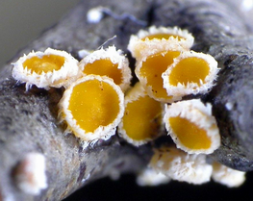  C. fagiseda, Lenggries, Fagus twig, 1600 m (leg. P. Karasch) |  | 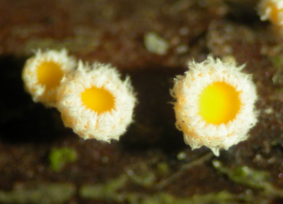  C. bicolor, Saarland, Quercus twig, leg./fot. B. Oertel)
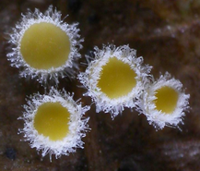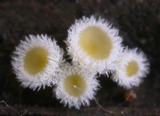  C. patula, Denmark, Jütland, Quercus leaves (leg. T. Lassoe, J. Petersen, B. Spooner, A. Raitviir, H.O. Baral et al.) | 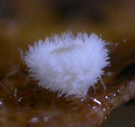  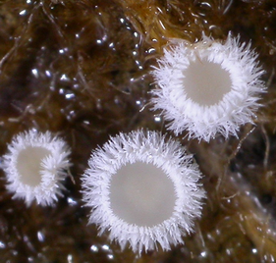  C. patula, S-France (leg. G. Garcia)  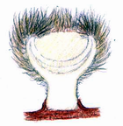  C. crystalligera (brown form), Brenckle 81, USA | 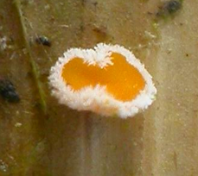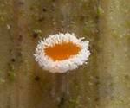  C. brevipila, Denmark, Jütland, Phragmites culm (leg. G. v. Ryckegem)  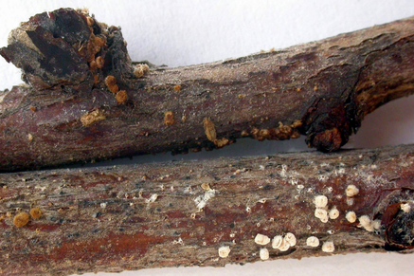  C. crystalligera (brown and white form), Weir 9203, USA
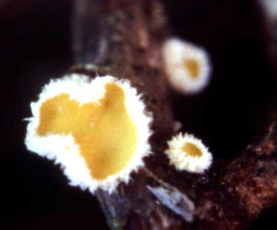  C. euphorbiae | 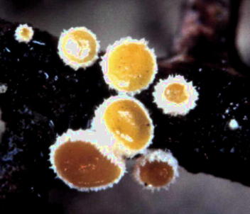 C. euphorbiae | 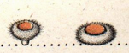  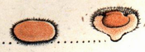  C. bicolor, from Bulliard (1789)

Key to species worldwide

1. Spores +26-53 x 2.4-3.2 µm, multiguttulate (very high lipid content), aseptate, asci +100-120 x 8-9.5 µm, arising from simple septa, cortex and base of hairs light yellowish-ochre (KOH more reddish), hairs 50-80 x 2.5-4.5 µm, walls 0.2-0.4(-0.7) µm, partly flexuous, without crystals, paraphyses subsyclindrical to narrowly lanceolate, scarcely exceeding the asci, on bark of deciduouos tree (S-Africa) .. “Lachnum“ brasiliense (Mont.) Haines & Dumont
Similar collection on wood of deciduous tree, Australia: spores narrower (+30-36 x 1.5-2 µm), hairs 150-180 x 3-5 µm, foxbrown near base. Lachnum abnorme and many other subtropical species with long-filiform spores belong in this group. Probably closely related to Capitotricha but perhaps worth a separate genus.

1. Spores KOH 6.7-9 x 2.3-2.9 µm, with a few minute LBs, hairs 90-110 x 4-5 µm, 5-celled, thin-walled (0.2-0.4 µm), no crystals, resinous hyaline matter at apex KOH-soluble, asci +58-70 x 5.4-5.8 µm, with croziers, paraphyses (narowly) lanceolate, 3-12 µm protruding, apothecia with thin stalk with strongly bulbose base, on wood of Erica, Macaronesia .... C. sp.

1. Spores max. 20 µm long, asci max. +75 x 7.2 µm, hairs usually with sparse to abundant crystals, walls in middle part +0.5-1 or upto 2 µm thick .. 2

2. Paraphyses ± narrowly lanceolate, +1.8-4 µm wide, exceeding the dead asci by 5-10 µm, spores mature 1-3-septate, +12-20 x 2.7-4 µm, with medium to high lipid content (multiguttulate), hairs 100-150 x 3-4 µm, with crystals, asci arising from croziers .. 2.5
2. Paraphyses more or less broadly lanceolate, *3-6 µm wide, exceeding the living asci by 10-30 µm (the dead asci even more), spores mature aseptate (but partly 1-septate when overmature) .. 3

2.5 Spores +12-15(-17?) x 3-3.3 µm, 1-septate, with high lipid content, paraphyses +2-2.5 µm wide, crystals not dissolving in KOH, croziers with minute perforation, on bark of stems of Cedronella, Macaronesica ... C. scabrovillosa
2.5 Spores +13-20 x 2.7-4 µm, fusoid, 1-3-septate, with medium lipid content, paraphyses +1.8-4 µm wide, crystals among hairs dissolving in 5% KOH (by forming drops), croziers with large perforation, on canes of Rubus, VIII, Asia, ?USA .. C. scabrovillosa (W. Phillips) Baral comb. nov. (= Lachnellula dabaensis Zhuang)

3. Mature spores multiguttulate (lipid content rather high: 3-4), hairs 60-120 µm long, 4.8-5.8 µm wide ..4.

3. Mature spores nearly eguttulate (lipid content very low: 0-1, rarely 2), hairs 90-160 or upto 300 µm long, 3-4 or 4-5 µm wide .. 5

4. Spores *12-14.5(-16) x 2.5-3 µm, without sheath, hairs *60-90 x 5-5.5(-7) µm, asci with croziers (with perforation), apothecia 0.5-1 mm diam., disc orange, on culms of Phragmites, V, 3 m, Denmark ... C. brevipila Baral & van Ryckegem sp. nov.

4. Spores *8.3-12.1 x 1.8-2.4 µm, with delicate sheath, hairs *86-120 x 4.8-5.8 µm, asci without croziers, apothecia 0.2-0.4 mm diam., disc yellow, on Mediterranean small culms of Poaceae, III, 20 m, Croatia (Dalmatia) ... C. minutissima Matočec sp. nov.

5. Asci arising from croziers (without perforation) .. 6

5. Asci arising from simple septa .. 7

6. Spores *(6-)7-10.5(-11,6) x (1.7-)2-2.5(-2.7) µm, hairs *90-190(-260) x 4.3-5(-6.3) µm, crystals usually present, absent in some collections, asci *(36-)45-55(-60) x (4.5-)5-6(-6.5) µm, apoth. 0.3-1 mm (without hairs), disc white to pale (-light) yellow, xerointolerant, on rotten leaves of Quercus, also Castanea, (II-)III-VI(-VII), 0-400 m, Europe (apparently only locally frequent) .. C. patula (Pers.) s. auct. non Pers.

6. Spores *9.6-14 x 2-3 µm, hairs 110-164 x 3-3.7 µm, crystals mainly on conical tips of hairs, apoth. 0.8-1.2 mm, disc dull to bright orange, xerotolerant, on dead twigs still attached to living Euphorbia spinosa, III-VIII, c. 450-650 m, Croatia (Dalmatia) .. C. euphorbiae Matočec sp. nov.

7. Apothecia white-haired in NW-USA (var. crystalligera), bright cinnamom-haired in SW-USA (var. cinnamomea Baral var. nov., both varieties growing associated in Midwest), cinnamom-haired specimens with amber-coloured warts resolving in KOH a bright purplish-vinaceous sap in the medium, paraphyses exceeding dead asci for (13-)20-35(-51) µm, spores +8-16.5 x (1.5-)2-2.7 µm, canes of Rubus parviflorus, VI-VII, W-USA, W-Canada .. C. crystalligera (Sacc.) Järv & Baral comb. nov.

7. Apothecia always white-haired, paraphyses exceeding only for c. +10-20 µm, apothecia xerotolerant, paraphyses projecting (10-)15-25(-30) µm beyond living asci .. 8

8. Spores *6-10(-10.7) x (1.5-)1.7-2 µm, asci *(40-)47-63 x 5-6.5 µm, canes of Rubus idaeus, (III-)V-IX, ?0-300-1600 m, Europe .. C. rubi (Bres.) Baral

8. Spores on average over *2 µm wide, apparently never on Rubus spp. .. 9

9. Spores *(6-)8-11(-13)((-14.5)) x (1.7-)2-2.7(-3) µm, sometimes 1-septate when overmature, asci *(45-)57-71(-85) x 6-6.7(-7) µm, apoth. 1-2.5 mm diam. (excl. hairs), stipe 0.2-0.5(0.7) mm long, bark (also wood) of twigs of deciduous trees (Quercus, Crataegus, Rosa, Alnus viridis, Betula, Corylus, Rhododendron), (XII-)III-VII(-VIII), 0-2000 m, Europe, ?USA .. C. bicolor (Mérat) Baral
Whether all these substrates bear the very same species is not sure; further studies are needed, at best in combination with molecular research. A collection on Purshia tridentata (twig, decorticated) from USA differed in a higher lipid content of the constantly fusoid spores.

9. Spores *(8.8-)10-15(-18) x (2-)2.5-3(-3.5) µm, partly becoming septate when overmature, asci *(60-)65-75(-85) x (5.5-)6-7(-7.5) µm, apoth. 0.7-2.5 mm diam. (incl. hairs), stipe 0.15-0.3 mm long, cupules and corticated twigs (also wood), rarely also on thicker branches and on petiole of leaves (fide M. Sukova), of Fagus, (I-)IV-VI, 200-1600 m, Europe .. C. fagiseda Baral

TRICHOSCYPHELLOIDEAE

Key characters of the tribe:

- apothecia relatively robuste, nearly always short-stalked (to sessile), mostly erumpent, long-haired
- yellow to orange disc - as a result of carotenoids in the paraphyses
- ectal excipulum of textura globulosa or prismatica-porrecta, usually gelatinized (t. oblita)
- medullary excipulum of textura intricata (gelatinized in stipe)
- lignicolous or corticolous
- drought-tolerance of complete apothecia in probably all taxa (growing on periodically dry substrates)
- anamorph of the Naemaspora- or Cytospora-type (pycnidia with microconidia born on phialids)

Brief history:

Formerly hidden in the large genus Dasyscypha Fuckel, Boudier (1907: 125) appears to be the first who separated the natural group of conifericolous taxa with yellow-orange disc and white hairs on generic level, as Trichoscypha Boud. ("Lachnellaceae"). Nannfeldt (1932: 298) changed Boudier's invalid name (homonym to Trichoscypha Hook f., Anacardiaceae) to Trichoscyphella Nannf., but separated taxa with globose spores in Lachnellula P. Karst. and transferred the group to the Helotiaceae despite the apothecia having long hairs. Müller & Ahmad (1962) included the brown-haired conifericolous taxa in Trichoscyphella. Dennis (1962: 183) united both genera under Lachnellula, but included also taxa on dicotyledonous trees and returned the group to the Hyaloscyphaceae. Dharne (1965), however, accepted only conifericolous species in Lachnellula and maintained placement in the Helotiaceae, while keeping the obviously close genus Perrotia Boud. on dicots in the Hyaloscyphaceae. Raitviir (1970, only conifers) and Spooner (1987, also dicots) accepted Lachnellula in the Hyaloscyphaceae but separated species with hemispherical ascus apices in Perrotia (partly conifericolous taxa recognized by me in Lachnellula). Kohn (1980, 1981) treated only dicot-inhabiting species in Lachnellula (tribe Trichoscyphelloideae), while Haines & Dumont (1983), followed by Baral (1984) and partly also Spooner (1987), used for these species a separate genus, Proliferodiscus Haines & Dumont. Haines & Dumont assigned the genus to the Arachnopezizoideae because of the presence of subicular hyphae.
I feel, however, that the conifericolous genus Lachnellula forms a rather natural group together with the non-conifericolous, mainly lignicolous genera Perrotia, Proliferodiscus, and Capitotricha (Raitv.) Baral, which may be today assigned to a separate family Lachnaceae which is separated from the more tiny Hyaloscyphaceae. Capitotrocha does not differ by habitus from Lachnellula, and even microscopic separation is not easy because of some intermediate species (L. ellisiana, Dasyscyphus scabrovillosus). Molecular research (.........) proves the connnection of ........ within the Lachnaceae. A fifth genus, Neodasyscypha Suková & Spooner (= Neodasyscypha Spooner), might also fall in this group for which the name Trichoscyphelloideae is here used. Further, perhaps less related genera of the Lachnaceae are Lasiobelonium Ell. & Everh., Proprioscypha Spooner, and Trichopeziza Fuckel. Hyphodiscus Kirschst. may be mistaken here but belongs close to Cistella in the Hyaloscyphoideae of the Hyaloscyphaceae.

KEY TO TRICHOSCYPHELLOIDEAE

 | colour and hemiamyloidy of excipulum | KOH-reaction of excipulum and hairs | KOH-soluble rose-brown hair granules | oxalate  crystals | Asci IKI | croziers (m = medaillon) | disc | substrate
Neodasyscypha | brown, IKI- | negative | purplish | - | bb | - | yellowish | angiosperm
Proliferodiscus | hyal. to brown, IKI rr | violet or negative | - | - (?) | bb/- | +/- | greyish to yellowish | angiosperm
Perrotia | hyal. to brown, IKI rr, also negative (?) | negative | purplish/ - | +/- | - | m/- | greyish-cream, sometimes yellowish | angiosperm
Lachnellula | hyal., IKI –, rarely rr | negative | - | -/(+) | -/rr/rb/(bb) | m/- | yellow-orange, rarely almost white | gymnosperm
Capitotricha | hyal., IKI – | negative | - | +/(-) | bb | -/+ | yellow-orange, rarely almost white | angiosperm

1. Ectal excipulum of textura oblita, hyaline or pale to dark olivaceous-brown (especially towards margin), stained permanently light to intensely (dirty) violet in KOH (often incl. hair bases, reversible with strong acid), gel in basal medulla and excipulum hemiamyloid; apical ring of asci euamyloid (BB) or IKI-, arising from simple septa or normal croziers (without perforation); paraphyses cylindrical to sublanceolate, sometimes with few small yellow LBs, with hyaline, granular intercellular matter, ascospores small, narrowly ellipsoid, few minute LBs; hairs thin- to thick-walled, hyaline, cylindrical, straight or curled, with scattered to dense, angular to rod-shaped or tuberculate warts, partly smooth (mainly in KOH or MLZ), *35-75 x 2.5-4 µm, at the stipe base forming a subiculum (at least when young); apothecia 0.3-1 mm diam., with a (bluish-)lead-greyish/whitish powder on the hairs, disc greyish or light yellow-ochre, centre often with proliferating hairs, sometimes many apothecia emerge from a common base, lignicolous ............. PROLIFERODISCUS Haines & Dumont
Small genus with temperate to tropical distribution. P. pulveraceus (Alb. & Schw.) Baral: Europe, Macaronesia, N-America, ?Australia, polyphagous on deciduous wood, phenol. mainly X-IV (excipulum brown, spores *4-8 x 1.3-2.2 µm, asci IKI BB, quite often associated with ist Cytospora-like anamorph: globose to flask-shaped blackish pycnidia with the same violet KOH-reaction in the peridium, and with phialidic microconidia); P. inspersus (Berk. & Curt.) Haines & Dumont (spores +2.3-5(-7) x 0.8-1.8 µm, asci IKI+) and P. earoleucus (Berk. & Br.) Haines & Dumont (= Lachnellula pittospori Kohn, spores +2.5-5 x 1-1.7 µm, asci IKI-): polyphagous, neotropical (excipulum hyaline). Spooner added 3 Australian species: P. caeruleoniger Spooner (with blue-balck hairs), P. dingleyi Spooner and P. alboviridis (Sacc.) Spooner. These apparently differ from typical Proliferodisci in the excipulum lacking the violet KOH-reaction. Furthermore, Spooner and Haines & Dumont report a dextrinoid (not hemiamyloid) MLZ-reaction for the excipulum which is possibly no true difference but a matter of the method. The Australian report of P. pulveracea by Spooner is possibly a different species (asci MLZ-, hairs pigmented, excipulum without KOH-reaction). Kohn's L. viridiglauca might also be a Proliferodiscus, but is characterized by a yellow KOH-reaction. Ref.: Haines & Dumont (1983), Kohn (1980, 1981, as Lachnellula), Baral (in Baral & Krieglsteiner 1985: 84), Spooner (1987: 632 ff.).
1. Ectal excipulum of dark grey-brown, isodiametric or slightly elongated cells, hairs light brown (in KOH dark grey-brown), apex hyaline, 80-200 x 3.6-4.8 µm, densely covered by large, globose/angular, loosely adhering warts and (esp. apically) golden-yellow (IKI partly deep blue after some minutes?!), KOH-soluble granules or lumps of resin, KOH dissolves a transient (few sec.!) faint pink-purplish-violaceous dye into the medium, subhymenium and hymenium in KOH also purplish-violet, medulla inamyloid, ascus base simple-septate, with euamyloid apical ring, ascospores small, narrowly ellipsoid-fusoid-clavate, eguttulate; paraphyses filled with yellow LBs; apothecia 0.8-2 mm diam., hymenium light to dark greyish-brownish to bright yellow: anamorph unknown, lignicolous ................................. NEODASYSCYPHA Suková & Spooner

Two known species: Type: N. cerina (Pers.: Fr.) Spooner (= Dasyscyphus cerinus (Pers.) Fuckel): Europe, N-America, Asia, Australia, polyphagous on deciduous wood, phenol.: mainly X-V (spores *5-9 x 2-3.5 µm, paraph. sublanceolate) ; N. subciboria (Rodway) Spooner: Australia, on "dead wood" (spores +7.5-10 x 2.5-3 µm, paraph. cylindrical). Ref. Spooner (1987: 589 ff., Suková 2005).
1. Both excipulum and hairs unstained in KOH, basal medulla hemiamyloid or not ..................................... 2

2. Asci with euamyloid apical rings (BB), arising from simple septa or normal croziers (in "Dasyscyphus" scabrovillosus with perforation); paraphyses narrowly to broadly lanceolate, strongly protruding beyond the living asci; hairs thick-walled (0.4-1.2(-1.7) µm), hyaline, cylindrical, c. 100-350 x 3-5 µm, densely warted by small to large ± globose warts; apical cell short, usually slightly enlarged and ± fusoid-lanceolate, ± smooth, usually with loosely attached rhomboid crystals or large druses on the top or among the hairs; ectal excipulum of medium to highly gelatinized text. prismatica-porrecta oriented at c. 10-55° towards surface, inamyloid; apothecia generally with yellow-orange discs; on dead dicotyledonous plants (twigs, leaves, fruits, canes) mainly in spring and early summer; anamorph unknown ............................ CAPITOTRICHA (Raitv.) Baral
Small genus comprising mainly the complex of the type species, C. bicolor (Bull. ex. Mérat) Baral. "Dasyscyphus" scabrovillosus differs in unenlarged, warted hair tips, crystals only on lateral hair surface forming globose drops in KOH, and medaillon-shaped croziers. The (sub-)tropical group around Lachnum abnorme (Mont.) Haines & Dumont (with very long filiform ascospores) might belong here, having more thin-walled hairs (+0.2-0.7 µm) without crystals. The relationship to C. bicolor is obvious from the molecular study of Cantrell & Hanlin (1997). In C. rubi sometimes an imperfect species of the intrahymenial parasitic genus Helicogonium suppresses the formation of asci by its phialides which may be mistaken for the anamorph of C. rubi. Ref.: Boudier (1910: pl. 501), Baral (in Baral & Krieglsteiner 1985).
2. Asci IKI- or with hemiamyloid (red, RR/RB), rarely euamyloid apical rings (BB, L. ellisiana), arising from simple septa or medaillon-shaped croziers; paraphyses cylindrical-subclavate to sublanceolate, scarcely protruding beyond the living asci (but strongly protruding in dead material), most species occur all the year round ........................................................................................3

3. Hairs with hyaline or brown walls, smooth or mostly granulate, never with reddish-brownish granules, no color reaction in KOH; always without crystals or druses on surface of hairs, rarely present in medullary excipulum; ascus apices hemispherical to subconical, wall only slightly thickened, IKI-, opening by a large pore, rarely operculate (L. abietis), or with an apical ring staining IKI-red (RR/RB), rarely blue (BB, L. ellisiana), arising from simple septa or medaillon-shaped croziers (or open croziers); Ascospores usually not allantoid; apothecia with yellow to orange discs, mostly shortly stipitate (stipe often partly hidden beneath bark), erumpent; basal medulla/excipulum inamyloid, rarely hemiamyloid (L. resinaria); anamorph: pale yellowish-reddish pycnidia of Naemaspora; on bark (sometimes on wood, needles or cones) of conifers, temperate (N- and S-hemisphere) ........................................... LACHNELLULA P. Karst.
3. Hairs *150-250 x 3-5 µm, hair walls hyaline but hair base or exterior of exciple brownish, hairs incrusted by red-brown granular exudate, therefore hair vesture distinctly brick-reddish or brownish, exudate intensely releasing a purplish-pink dye in KOH, rhomboid crystals abundantly present among hair base and in excipulum; ascus apices hemispherical, IKI-, operculate, arising from ± medaillon-shaped croziers (partly not rejoining); spores allantoid, *12.5-20 x 3-4.5(-5) µm, aseptate within the living asci, with some minute LBs, later usually septate; paraphyses filiform, with or without yellow LBs (living state); basal excipulum hemiamyloid; apothecia with a hidden short stipe immersed in substrate, disc cream or yellowish-brownish; anamorph unknown; on woody plant substrate of Magnoliophytina, temperate, northern hemisphere .............................................................................PERROTIA Boud. ss. str.
The type species P. flammea (Alb. & Schw.) Boudier is figured in Boudier (1905-10: pl. 321). A few further species have been assigned to the genus. At least one of them, Perrotia distincta (Peck) Haines (= P. phragmiticola (P. Henn. & Plöttn.) Dennis), seems not to belong in Perrotia: Asci with conical, inamyloid apices; ascospores ±straight, 1-septate within living mature asci, *16.2-22 x 3.2-4.1 µm; apothecia with deep orange-pink discs; on culms of Phragmites, Europe. Cantrell & Hanlin's (1997) molecular study also indicates that P. distincta is not congeneric with P. flammea.

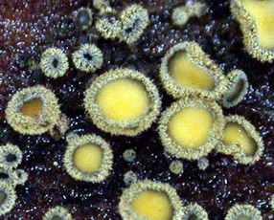  Neodasyscypha cerina | 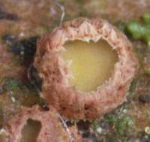  Perrotia flammea

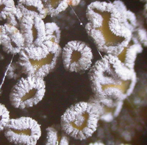  Proliferodiscus pulveraceus, mature (live) | 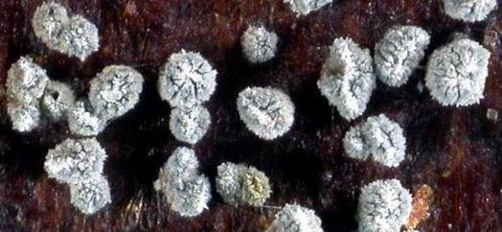  Proliferodiscus pulveraceus, immature hydrated apothecia (dead state)
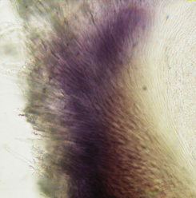  Proliferodiscus pulveraceus, ectal excipulum in KOH  reacting reversibly bright dirty purplish-violet  (disappearing when neutralizing with acid) | 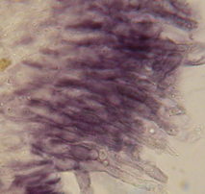  P. pulveraceus, hairs in KOH reacting purplish-violet | 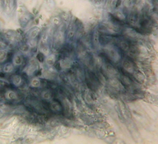  Hemiamyloid ectal excipulum of P. pulveraceus, KOH-pretreated (heated), neutralized with acid to remove the violet reaction, then adding IKI and rinsing with water
Proliferodiscus pulveraceus

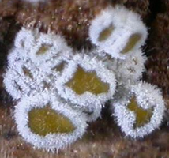  Proliferodiscus cf. inspersus | 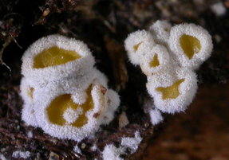  Proliferodiscus cf. inspersus
Proliferodiscus cf. inspersus

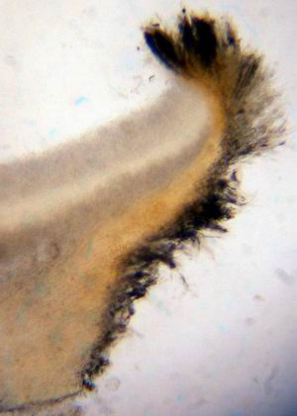  Proliferodiscus tricolor, Section in KOH 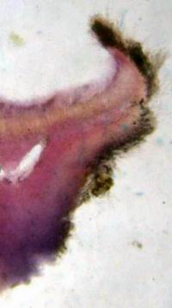  Hemiamyloid excipulum: lilac-violet IKI-reaction of after KOH-pretreatment (heated)  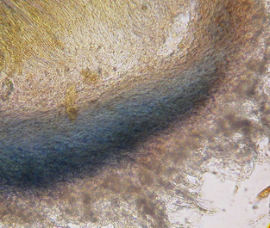  Blue IKI-reaction after rinsing with water | 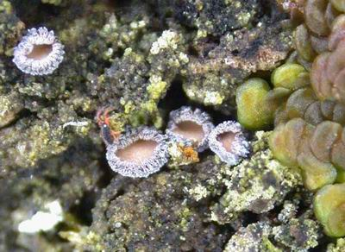  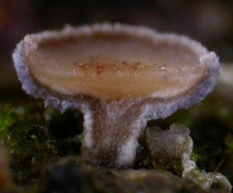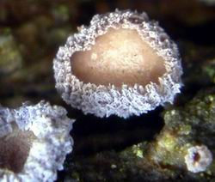  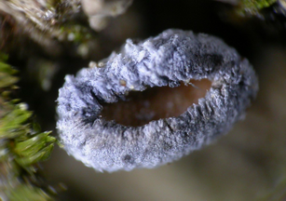  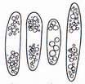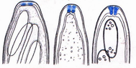
Proliferodiscus tricolor

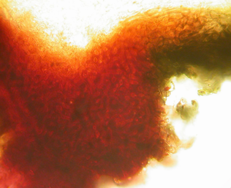  Proliferodiscus olivaceus, excipulum in IKI | 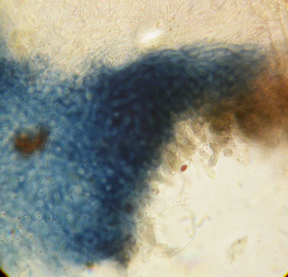  Excipulum in IKI after KOH-pretratment (heated) and rinsing with water
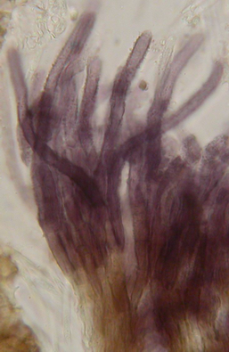  Hairs staining violet in KOH  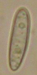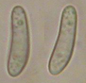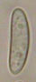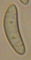 | 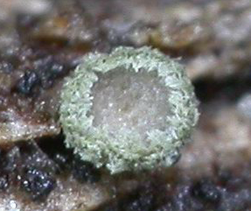  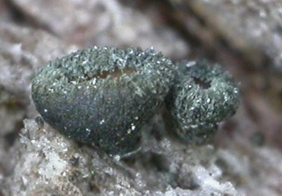
Proliferodiscus olivaceus

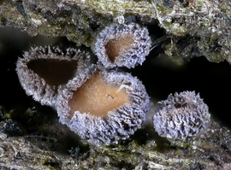 | 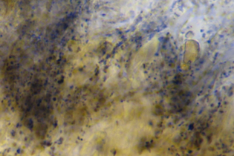  violet granules on hairs and excipular cells
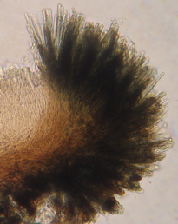 | 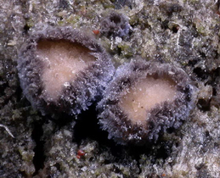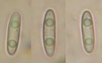
Proliferodiscus violaceus

Key to species of Proliferodiscus

All species with hemiamyloid excipulum. Many species with inamyloid asci, but P. pulveraceus, P. inspersus and P. tricolor usually IKI blue.

1. Ascospores eguttulate or with a few minute LBs, relative lipid content very low (0-1), excipulum turning faintly to strongly dirty violet in KOH 2
1. Ascospores with prominent guttules (many small or a few medium-sized to large LBs), relative lipid content medium low to high (2-4), excipulum KOH- (but hairs partly violet in KOH) 5

2. Apothecia entirely hyaline, tissue unpigmented, ±subtropical P. inspersus
2. Apothecia externally bright grey, tissue light brownish-olivaceous -> 3

3. asci IKI-, asci with croziers, spores KOH 6-8 x 1.7-1.9 µm, Ölm. 1-2, on wood & bark of Ulex europaeus (F, Maine & Loire) (Md 8666A, leg. B.Duhem, HB-) -> P. spec. (?only a variant of P. pulveraceus)

3. Asci IKI bb .... 4

4. Asci arising from croziers, spores *4-7 x 1.5-2 µm, pycnidia short to long conical, conidia *1.8-3 x 1.4-1.7 (-1.8?) µm cyl. to ovoid, conidiogenous cell *10-12 x 1.3-2 µm, on a wide range of deciduous wood (hanging or lying on ground), also on bark X-VI, 50-620 m -> P. pulveraceus
4. Asci arising from simple septa, spores *5-6.5 x 1.5-2 µm, Ölm. -2, pycnidia globose, conidia *2-4 x 1.1-1.4 µm, ± cyl., conidiogenous cell *8-15 x 1-1.7 (-2?) µm, mainly on still standing Prunus spinosa P. pulveraceus (possibly no distinct taxon, 1x both in association)

5. Spores*(8.7-)10.5-15(-19) x (3.6-)3.8-4.7(-5.7), asci *65-76 x 10-11 µm (†51-66 x 7.3-10 µm), apex (†) ± conical, IKI-, hairs without violet warts but partly turning violet in KOH, apothecia 0.3-0.8 mm diam, with greenish-olivaceous hair vestiture, bark of Eremaea & Verreauxia SW-Australia P. olivaceus sp. nov.
5. Spores *(2.3-)2.6-3.5(-3.7) µm wide, asci *7.3-9.5 µm wide (†5.5-7.5 µm), hairs especially on flanks with scattered, minute, dark violet warts (in KOH greenish-blue), hair vestiture of apothecia therefore usually with a ± distinct bluish-violet tint, walls never turning violet in KOH 6

6. Asci *50-73 µm long (†46-58 µm), apex (†) hemispherical to slightly truncate, IKI-, terminal cells of paraphyses *13-20 x 1.6-2 µm, spores *(7.5-)8.5-12(-13) x (2.3-)2.6-3(-3.3) µm, containing 2(-4) large and partly a few small LBs, hairs 60-115 µm long, ectal excipulum pale to light fox-brown, apothecia 0.3-0.8 mm diam, 0.2-0.3 mm tall, bark of Acacia, Allocasuarina, Calothamnus, SW-Australia
P. violaceus sp. nov.
6. Asci *80-110 µm long (†69-92 µm), apex (†) conical(-truncate), with IKI deep blue apical ring (rarely IKI-), terminal cells of paraphyses *21-45 x 2-2.8 µm, spores *(9-)10.5-14.5(-17) x (2.6-)2.8-3.5(-3.7) µm, containing several large and small or many small LBs in each half, hairs 70-200 µm long, ectal excipulum hyaline, apothecia 0.5-3 mm diam, 0.3-0.9 mm tall, bark of Quercus, Central, N- and W-Europe, N-America Pr. tricolor

Key to the accepted species of Perrotia

All species with inamyloid asci. P. distincta and P. flammea with hemiamyloid excipulum, P. microscpora and perhaps further species with inamyloid excipulum. KOH-extractable granules so far with certainty only known on P. flammea. Still to be included: P. populina and ???

1. Asci with ± distinctly conical apices, ascospores ± straight, consistently 1-septate within living asci, *14-22 x 3-4 µm, hair wall †0.5-1.5 µm thick, disc bright orange-red, exterior of apothecia yellowish-brownish, culms of larger grasses, wood of Lonicera, Europe, N-America ....................... P. distincta
1. Asci with broadly rounded, ± hemispherical apices, ascospores straight or allantoid, always aseptate within living asci .. 2

2. Ascospores ± cylindrical, straight to distinctly allantoid, 9.5-24 x 3-5 µm, hairs 150-300 µm long .. 3
2. Ascospores ellipsoid-clavate-ovoid or fusiform, not or only scarcely curved, hairs???? .. 4

3. Hairs ± densely covered by rusty-orange to purplish-rose, KOH-extractable granules, apothecia ± sessile, on wood (rarely bark) of various angiosperm trees and shrubs, Europe, N-America, Asia ....................... P. flammea
3. Hairs with bright sulphur-yellow, KOH-inert resinous exudate, apothecia with distinct stalk, on bark of Casuarina, Australia ........................ P. sphaerula
3. Hairs hyaline, granulate, apothecia with short stalk, on twigs of Aristolochia, New Zealand ............. P. alba

4. Ascospores 5.5-8.5 µm long, hairs without pigmented exudate, on branches of Halocarpus, Kontinent? ....................... P. microspora
4. Ascospores 10-18 µm long .. 6

6. Ascospores strongly fusiform-rhomboidal with acute ends, with two large central LBs, on bark of Nothofagus, New-Zealand ......... P. apiculata
6. Ascospores cylindric-ellipsoidal, ?eguttulate, hairs with rusty-ochre-orange?? exudate, on branches of Quercus, California ............ P. succina

 | sp. | LC | sept | asci | IKI | apex | croz | hairs | hair wall | pigm. Gran. | exc. K+IKI | host
P. flammea | *9.5-24 x 3-5 | 0-1 | 0(1) | *78-136 x 10-15 | - | ±hemi | + | 150-300-x 3.3-5 | 0.3-1.2 | rusty-purplish-ochre | blue-viol. | wood (rarely bark)
P. sphaerula | †14-21 x 2.8-4 | ? | 0(1) | †80-125 x 9.5-12 | - | hemi | +? | 150-220 x 3-5 | thin/thick | yellow | ? | bark
P. alba | †12-7 x 3.5-4.5 | ? | 0(1) | ?+60-67 x 8-9 | - | ±hemi | ? | -200 x 3-3.5 | thin/thick | - | ? | ?
P. apiculata | +?12-18 x 3.5-5 | 5 | 0 | ?+75-90 x 9-12 | - | ±hemi | ? | 30-120 x 3-4 | thin | - | ?
P. tricolor | *9-16 x 2.3-3.7 | 3-4 | 0 | 80-110 x 7.3-9.5 | 3bb / - | con | + | 70-150 x 2.4-4.8 | 0.2-0.3(-0.5) | black-viol | blue-violet | bark
P. succina | †10-14 x 3-5 | ? | 0 | †110 x 10 | - | hemi | ? | ?? x 2.5-3 | thin | orange | ? | wood?
P. microspora | ?*5.5-8.5 x 2.8-3 | ? | 0 | †35-50 x 5.5-6.5 | - | hemi | + | 70-130 x 2.5-3.5 | thin | - | -# | bark (?)
P. coccinea | †14-20.5 x 3-3.7 | 1-2 | 1 | †66-83 x 7-8 | - | con | ± | 70-100 x 3-4.2 | 0.7-1 | - | blue | wood
P. distincta | *16-22 x 3.2-4.1 | 2 | 1 | *75-85 x 8.3-8.7 | - | con | ± | -130 x 3-3.5 | 1-1.5 | yell-ochre | greyish | culms
#fide G. Verkley (pers. comm.)

