Cosmospora sp.

France, Ariège : Rimont, Saurine, 10 Feb. 2009, on stromata of Diatrypella quercina on Quercus bark, JF 09005.

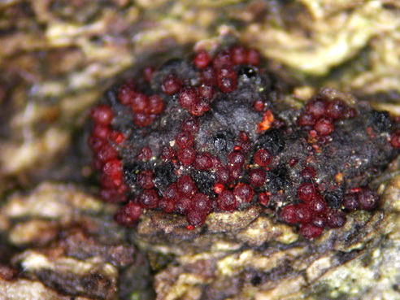 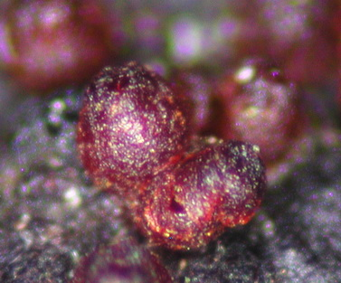 Ascomata gregarious on old stromata of Diatrypella quercina, superficial, nonstromatic but firmly attached to the substrate, subglobose 300-380 µm high x 250-340 µm diam with a discoid apex 120-150 µm broad, tuberculate to crown-like; wall blood red, KOH+, roughened, 60-70 µm thick at sides, thicker at apex, composed of two intergrading regions: outer region textura angularis to prismatica, 40-50 µm thick, composed of small pigmented thick-walled cells, cell wall 2-3 µm thick, inner region textura prismatica, composed of flattened cells with hyaline walls, thick-walled outwardly, thin-walled inwardly. Apex composed of palisadic pigmented elongated cells with rounded ends.
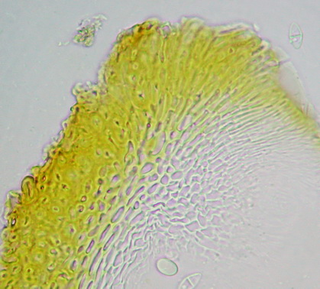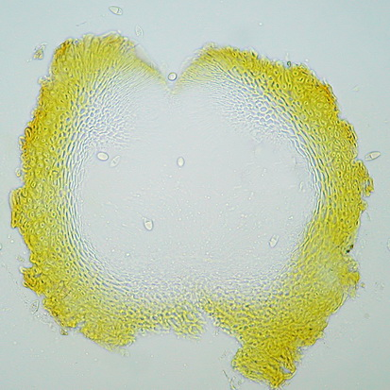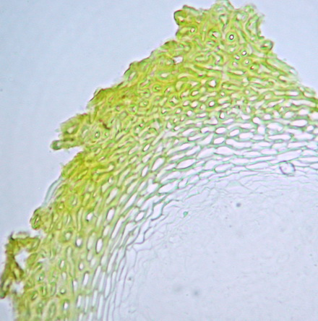

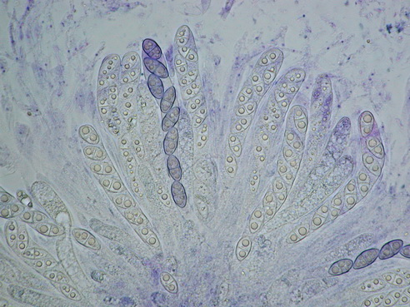 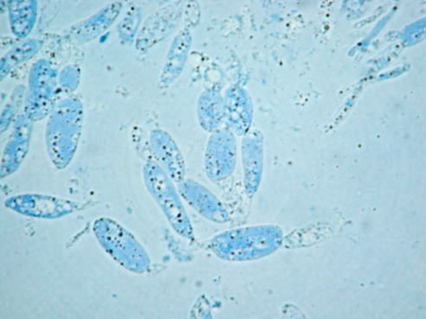 Asci cylindrical slightly clavate, 110-130 x 12-14 µm, with eight obliquely uniseriate ascospores somewhat biseriate in upper part, apex simple. Hamathecium composed of persistent paraphyses moniliform at base, filiform above. Perithecial contents faintly salmon-coloured.

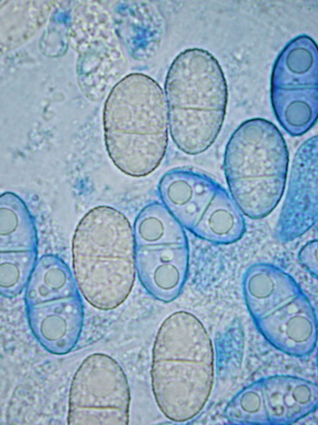 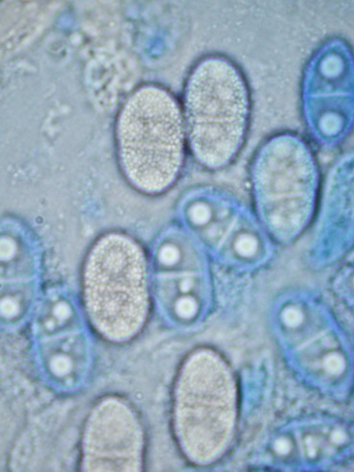 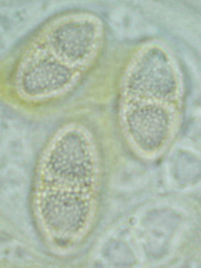 Ascospores 15-18.5 x 9.5-10 µm, broadly ellipsoid, equally two-celled, hardly to not constricted at septum, first hyaline to yellowish grey at maturity, wall conspicuously pitted.

