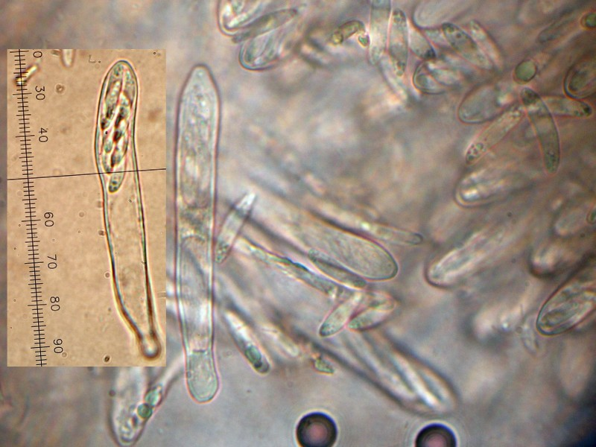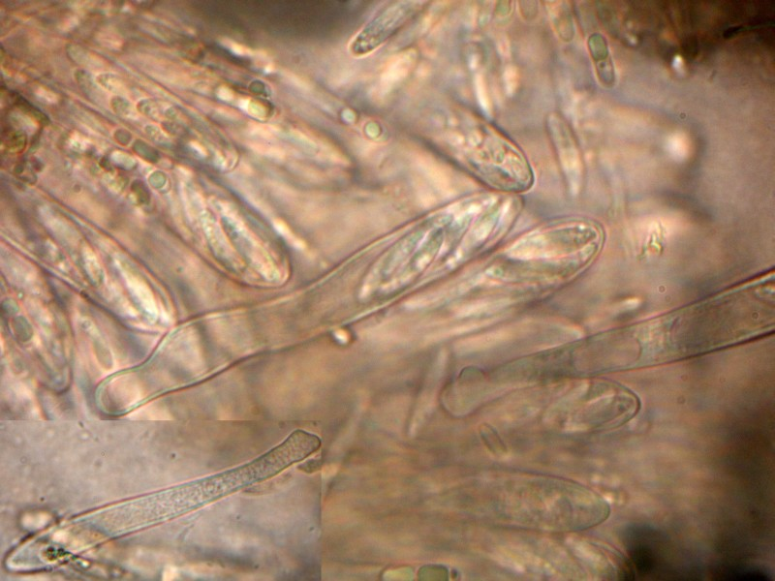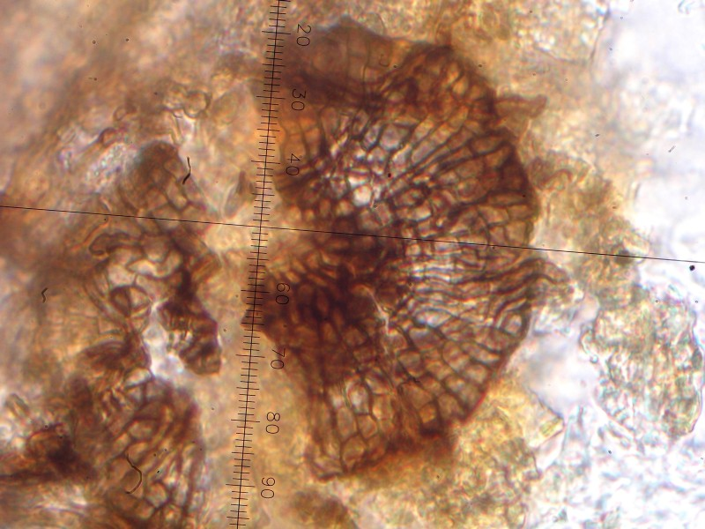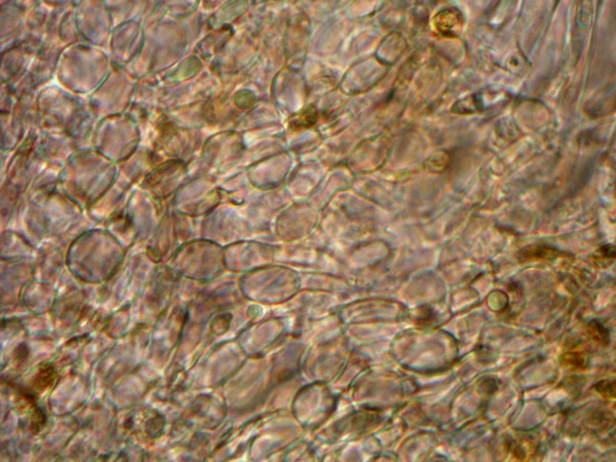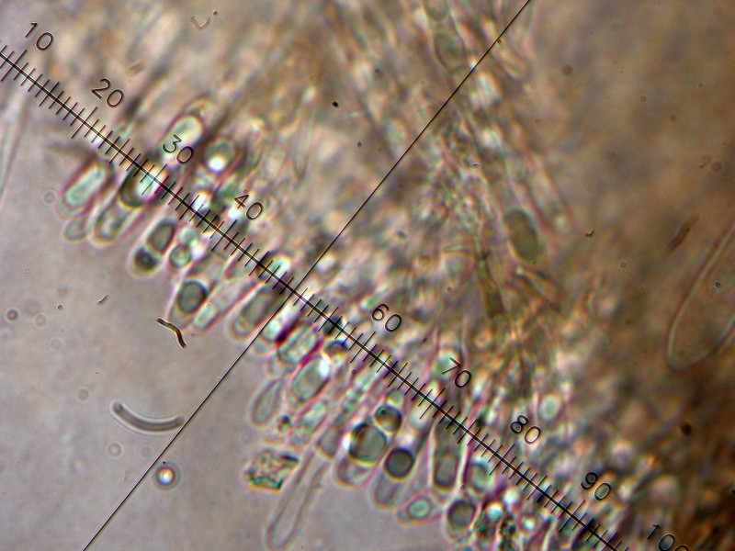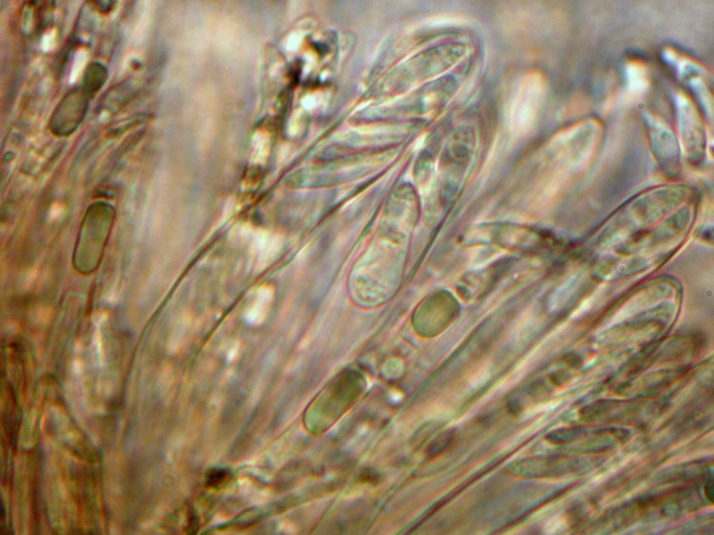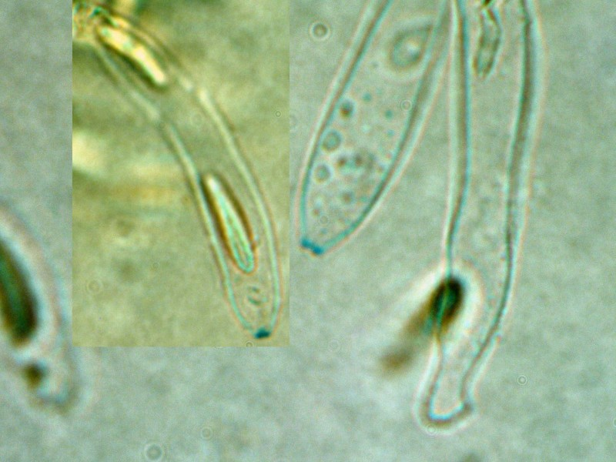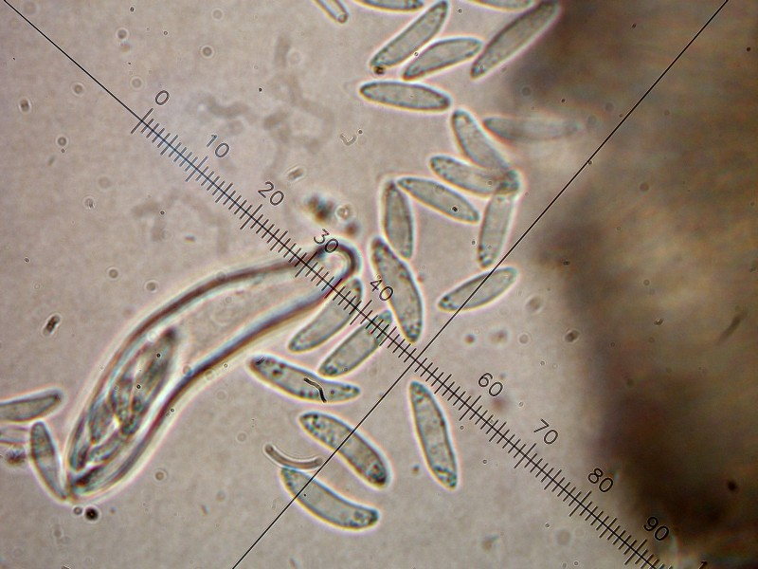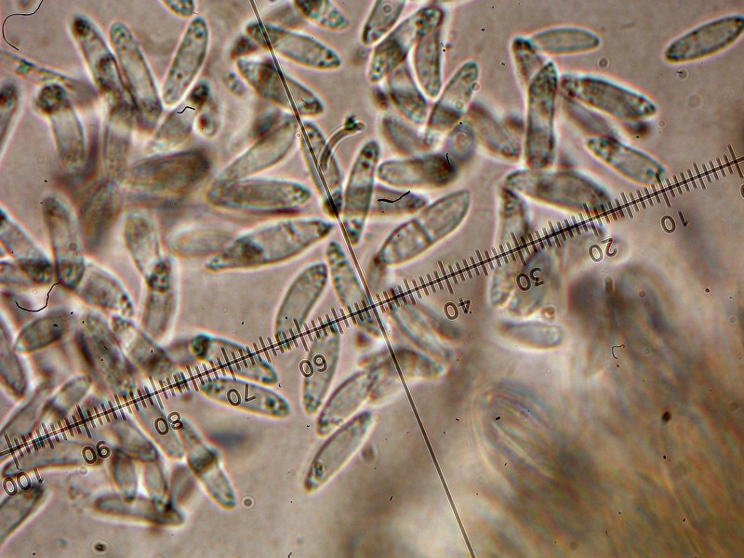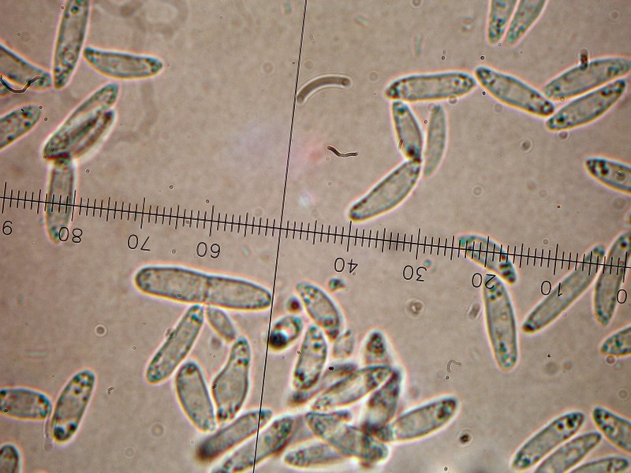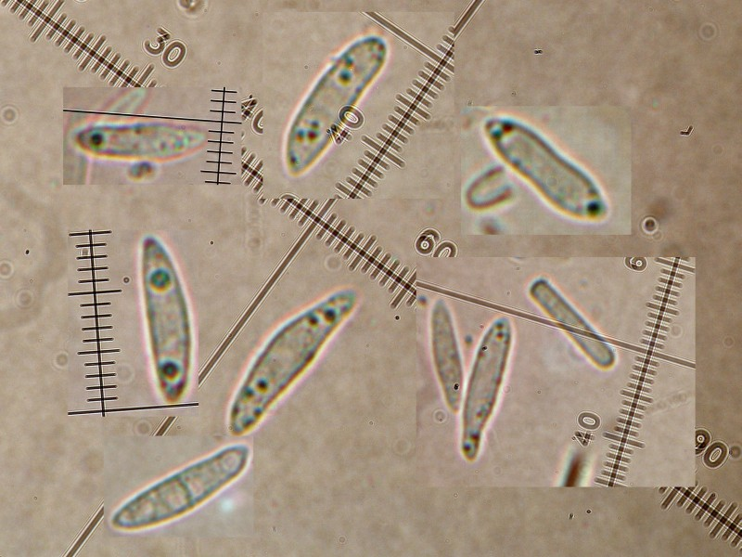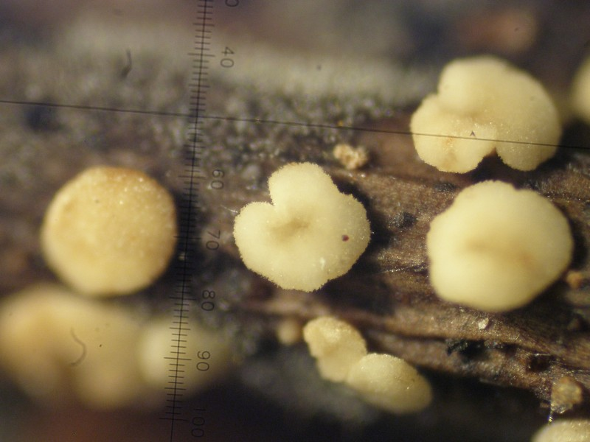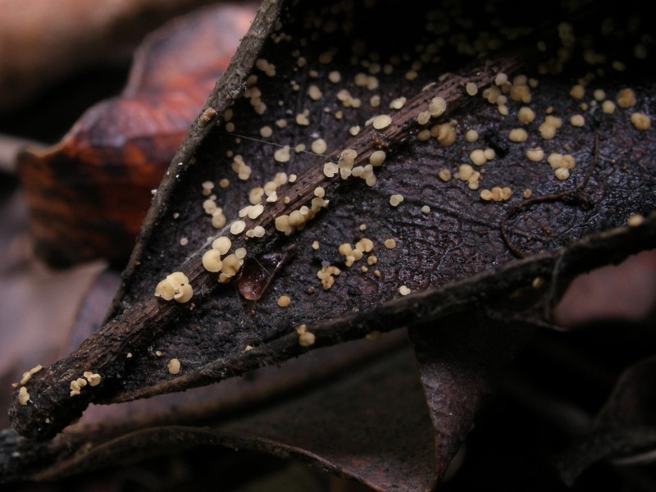

Collected in Valencia (Spain), 1 meter above sea level, on 26-12-07.
Apothecia gregarious, sessile (or subsessile), on both sides of fallen leaves of Ceratonia siliqua. Reaching 0,7 mm. More than 150 apoth. together. Whitish cream to pale ochraceous when old.
Asci: 8-spored, with croziers, MLZ + (Water + Melzer).
Spores: hyaline, ellipsoid to fusoid, often with strange forms, tiny polar guttules when alive, 2 polar (up to 1,5 µm) guttules when dead? (9)12-17 (20) x 2,5-3,5 (4). Only a few two celled.
Paraphyses: x 2-3,5, with yellowish pigment.
Ectal excipulum of textura angularis to prismatica. Brown basal ring present. “Hairs” apically rounded, 4-septate?,with same pigment as in paraphyses.
Can it be Calycellina leucella (Karst.) Dennis ex Müller?
Thanks a lot for your help!

Raúl Tena Lahoz.

