Xylaria arbuscula Sacc.

Germany: Brandenburg, Postdam, Botanical garden, ferns greenhouse, 29 Oct. 2009, BRD 3544/33, on a branch of Quercus on the ground, leg. det. V. Kummer.

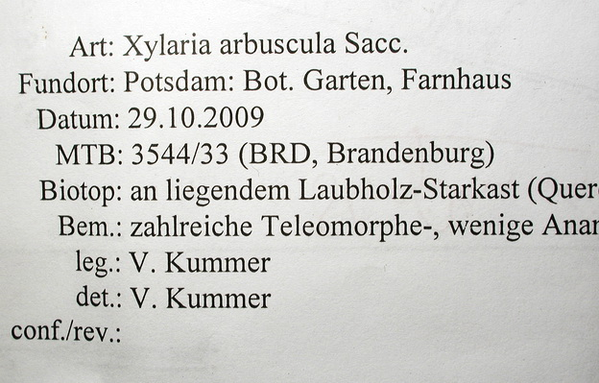 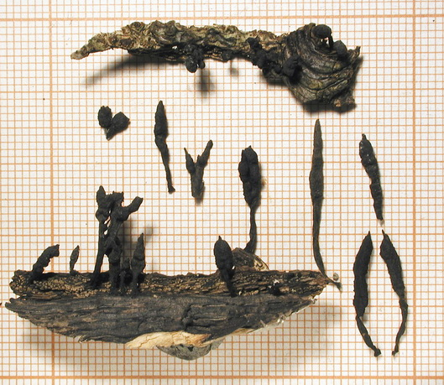 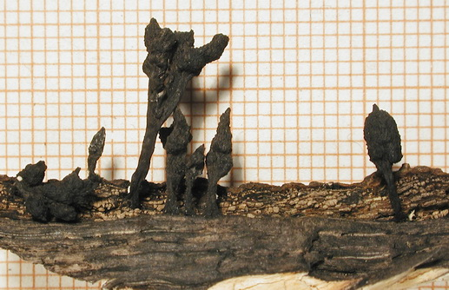 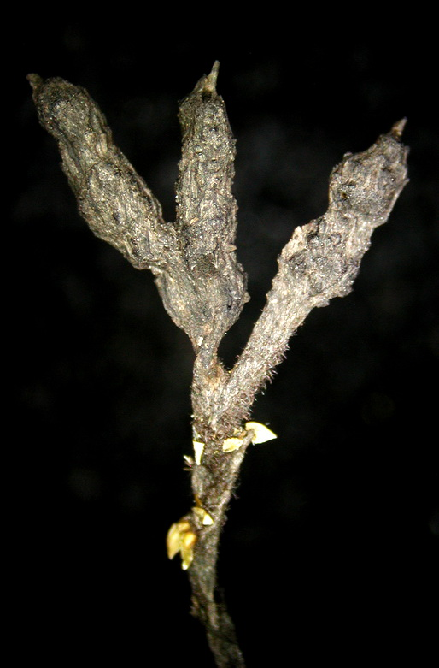 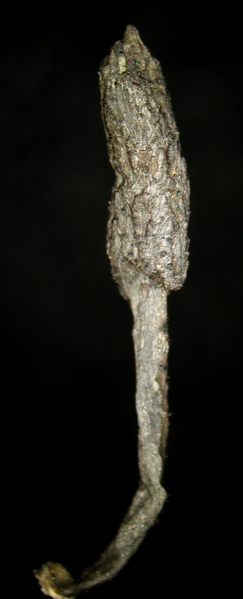 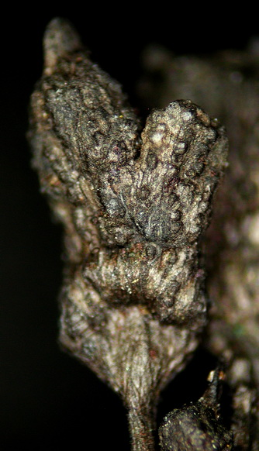 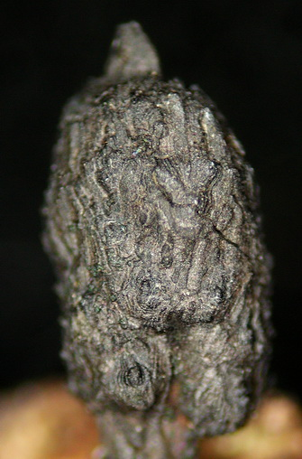 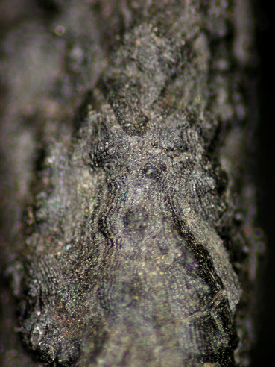 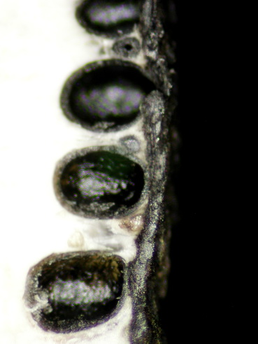 Stromata erect, scattered to gregarious, simple to ramified, 5-24 mm total height, the fertile head 3-11 mm high x 1.5-2.5 mm diam, cylindrical to slightly fusiform or flattened, hard-textured, with a pointed sterile apex, long-stipitate to nearly sessile, the stipes well-defined, 1-15 mm high black, glabrous to hairy. Stromatal surface silvery grey to blackish, without visible perithecial contours, roughened by persistent grey to dull black carbonaceous elongated plaques and undulating lines furrowing the surface of the underlying stromatal crust; crust carbonaceous, 80-120 µm thick, interior white, spongy, solid. Perithecia fully immersed, subglobose to obovoid, 0.4-0.5 mm diam. Ostioles hemispherical to discoid, inconspicuous, ca. 80 µm diam.
JF 05071 leg V. Kummer

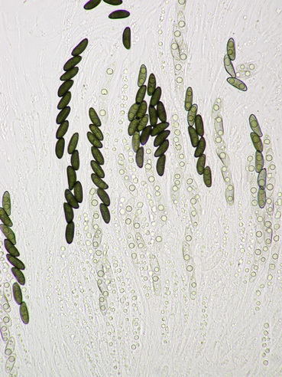 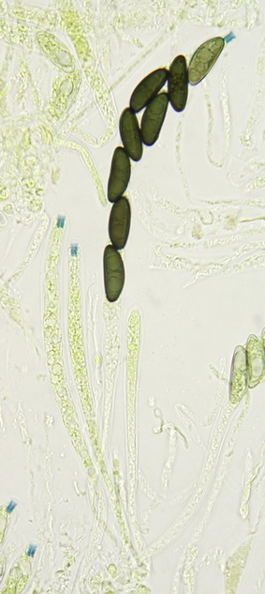 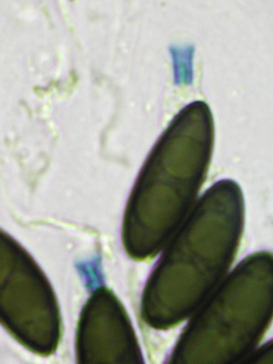 Asci cylindrical, 8-spored, 190-210 µm total length, the spore-bearing parts 82-110 µm long x 7-8 µm broad, the stipes 64-72 µm long, with apical ring tubular with flared upper rim, 3.5 µm high x 2.5 µm broad, bluing in Melzer’s reagent. Paraphyses filiform, copious.
Melzer’reagent
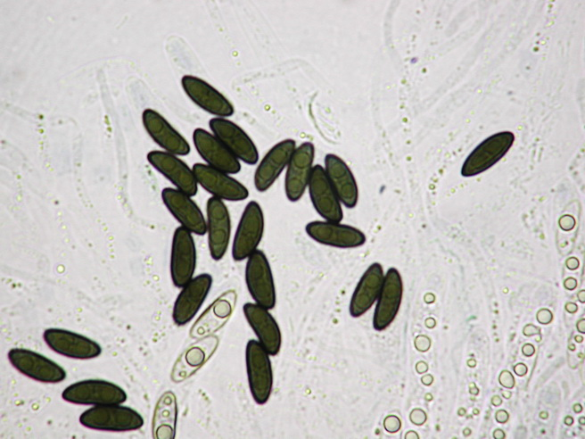 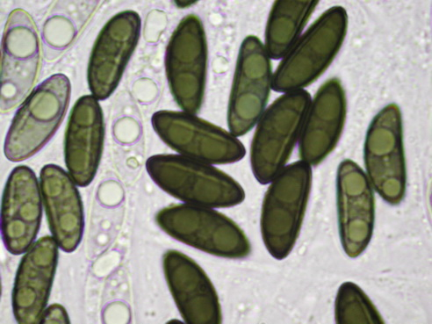 Ascospores 12-15 x 5.5-6 µm, ellipsoid-inequilateral with narrowly rounded ends, uniseriate to often irregularly biseriate in upper part of the ascus, medium brown (olive brown when fresh), smooth, biguttulate, with a conspicuous straight germ slit 3/4 spore-length on the ventral side.
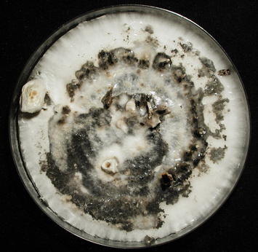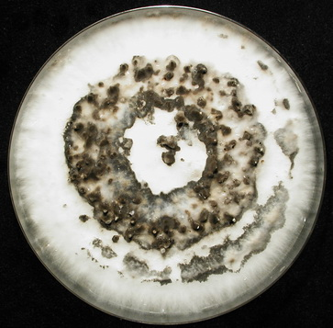
Cultures on YMG

Comments: Six collections from Postdam greenhouses were examined so far, all highly similar in macro and micro morphology. It is assumed they represent Xylaria arbuscula Sacc., the type of which was collected in such greenhouses in Italy. The stromata vary from typically ramified to simple but all feature a similar carbonaceous crust with dull black plaques and furrowed surface, and very similar asci and ascospores. When compared with tropical collections from French West Indies, Taiwan and Thailand referred to X. arbuscula based on stromatal habit, ascospores dimensions and germ slit morphology, the material from Postdam appears slightly different in having a slightly thinner carbonaceous crust (80-120 vs 120-170 µm thick), different external appearance of stromatal surface and germ slits of ascospores averaging slightly longer. Xylaria arbuscula as currently accepted is a pantropical taxon featuring variations in stromatal surface and ascospore morphology. The significance of these variations remains to be evaluated based on morphology of cultures and analysis of DNA sequences.

The following collection comes from the same place and features somewhat stouter stromata along with anamorphic stromata that are ramified and flattened.

